World Plumbing Council 2013 Education and Training Scholarship Report
A rendezvous with Germany Plumbing Education and training system

An identity approach to vocational education and training is being considered as a probable aid in reducing the early dropping out of students from vocational training. The results of this study found that Germany’s vocational training system is premised upon such identity principles and is therefore a model of such an approach. This approach is engaging, imaginative and contributes significantly to the country having the highest rate of youth employment in Europe.
2013
Lennox Shade
World Plumbing Council
1/1/2013

REPORT

A Rendezvous with German
Plumbing Education and Training
System

By
Lennox shade MA, BSc (Hons)

World Plumbing Council
Education and Training Scholarship
2013

World Plumbing Council
Scholarship # 2013-10

September, 2014

Notice

This document contains the observations, interpretations and conclusions of the World Plumbing Council 2013 Education and Training Scholar and do not necessarily reflect the views of the World plumbing Council or its members. The structure and presentation of material are the ideas of the scholar as well and not in any way imply the expression of the Secretariat. This document has been reviewed in accordance with the World Plumbing Council administrative and peer procedures and has been approved for publication. Trade names and commercial products mentioned do not constitute recommendation or endorsement.

About the world plumbing council

WORLD PLUMBING COUNCIL
The World Plumbing Council (WPC) is an international organization which aims to develop and promote the image and standards of the plumbing Industry worldwide! WPC mission statement is: "To promote the role of plumbing in improving public health and safeguarding the environment, by uniting the World Plumbing Industry, for the benefit of all.”

ABOUT THE WPC 2013 SCHOLAR

This snippet is about the 2013 WPC educational and scholarship winner.

I am a 56 year old second generation plumber married to the lovely Elizabeth a physical education teacher for the past twenty-five years. I am the father of two children: a 23 year old final year medical students and my son a 22 year old National Science Scholarship Winner studying at the University of Waterloo in Ontario, Canada.
Yes, plumbers do make good husbands and fathers
I am a devout Seventh Day Adventist Christian who believes and is awaiting the second coming of Jesus.
Although I was born into an environment surrounded by pipes, fitting and related tools plumbing was not my first choice of a trade. As a precocious child attempting to make sense of the many pieces of tools in my father tools box were often efforts in frustration and I did not naturally gravitate towards it later. When the beautiful trade was thrusted upon me, however, I never questioned it nor objected; today I’m glad I didn’t. I entered the National Apprenticeship Centre in 1975 to study electrical installation. Because that class was filled I was sentenced to the plumbing class. Today I’m glad I was. Such was the effect that initial plumbing program had on me I have never stopped studying up to this day. I hold an Assistant Plumbing craft Certificate, National Plumbing Craft Diploma, Technician Certificate in Building, International Diploma in Plumbing, Caribbean Vocational Qualification Level II Certificate in plumbing, International Diploma in Heating Air Conditioning and Refrigeration, Diploma in Water and Wastewater Plant Operation, Certificate in Health Safety and Environmental Management, Technical Teachers Diploma, AutoCad level I, BSc (Summa cum laude) Education with concentration in vocational education and MA in Educational Psychology. Currently I am completing an MPhil in education hoping for an upgrade towards a PhD in education. This is what plumbing has done with me; it has opened up a tremendous capacity within to know in order to supplement what I can do. It has made me a more theoretical practician.
The beautiful trade has instilled in me a love for practical work too, and my capacity for it has grown. Over the years I acquired considerable experience in various aspects of plumbing through working with several international and local Companies including SP Wallace International, George Wimpey Ltd, Norde France international, Kellogg International and Bechtel International. I have worked as a Technical Officer at our National Training Agency for two years. Currently I am a senior plumbing instructor at my Alma Mata. My last real plumbing engagement was the Sunday before I flew to Germany to take up the scholarship.
These two areas, work and study, have integrated within me to good effect and together they in turn have given me a unique perspective on life and education. Life in this post-modernist globalized world conveys the impression that education is all about obtaining employment which has become very uncertain of late. This is a narrow view indeed. To me education is vastly more than that. It’s about developing the entire being to the highest level possible throughout life. And this education is essentially a socio-cultural process that occurs best in the real world environments where things are actually constructed, built or where the specific experience is unfolding. As social being learners are seen as interactive participants in conjunction with teachers as knowledgeable others modeling appropriate behavior. Of the educational pursuits employed in this process vocational education is the sweetest and plumbing most sublime. It changes who you are by changing the way you view, interact and respond with the world. It defines who you are. It liberates and gives you true freedom, an absolute type like the concept of freedom espoused by a former American Supreme Court Judge. To him this freedom allows the autonomy to determine not just the nature, meaning and purpose of existence, but also of the self, the universe and the meaning of the mystery of life itself.
In this respect I am deeply indebted to the beautiful trade and how it has engaged me, the cognitive capacities it has given me, the intellectual stimulation it has triggered within me as well as the moral and ethical code it has imposed upon me to shape my finer social sensibilities. These qualities have nourished within me a love for work, learning and an exceedingly great delight in passing down to the next generation of plumber the accumulated wisdom (the attitude) of the beautiful trade.
I wish to be nothing else.
Lennox Shade

Table of Contents

About World Plumbing Council……………………… ……………………….iv
Snippet about WPC 2013 Scholar……………………………………………….. v
Acknowledgements viii
SECTION 1 15
1.0.0 Introduction 15
SECTION 2 Local Context 18
2.0.0 Introduction 18
2.1.0 Plumbing training and industry realities 18
2.2.0 Impact on industry 19
2.3.0 Realities in vocational schools 19
2.4.0 An identity approach 20
2.5.0 Theoretical underpinning 21
2.6.0 Benefits of an identity approach 23
2.7.0 Study/tour purpose 24
2.8.0 Study/tour goals and objectives 25
2.9.0 Questions guiding the tour 26
2.9.1 Sites observed 27
2.9.2 Methodology 28
2.9.3 Limitation 28
SECTION 3 Germany at a glance 30
3.0.0 Introduction 30
SECTION 4 Findings 52
4.0.0 Introduction 52
SECTION 5 Discussion 75
5.0.0 Introduction 75
SECTION 6 Conclusion implication and recommendations 99
Bibliography 109
Appendix…………………...…………………………………….111

Acknowledgements

This educational study/tour was a fantastic learning experience; indeed a growth experience. It may have started as an exploration of plumbing educational and training practices. However, as the tour unfolded it gradually was transformed into a more encompassing, historical, social, cultural and technological experience and how the plumbing craft not just fitted into this milieu but shaped it further contributed to the richness of the experience.
The German experience was deeply engaging. Everywhere there were natural objects and wonders, the monument and achievement of the past to captivate the mind from the gorgeous Rhine to the majestic Cologne Cathedral (if painted white would have appeared as the gateway to the city of the eternal God). Even in places where nothing
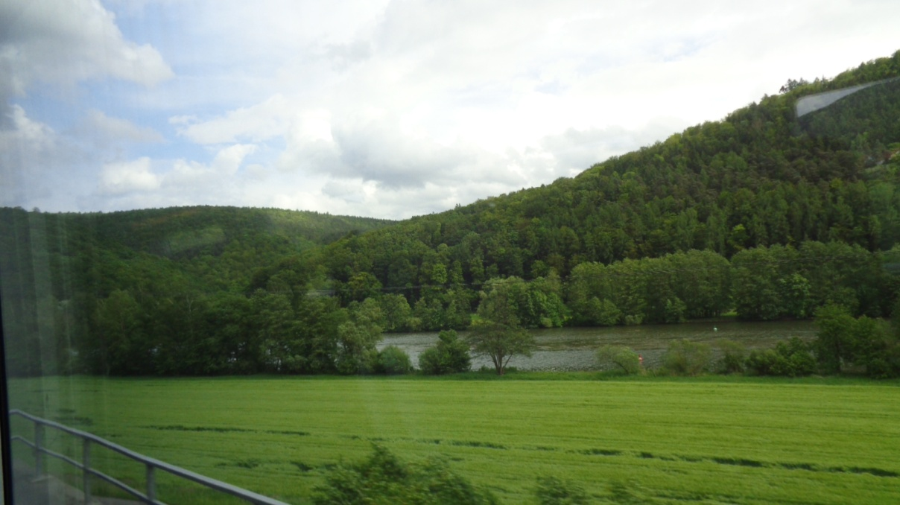
Figure 1. Picture of lush green German countryside

seemed normative there were unwritten meanings and purposes that engage the mind in silent intellectual discourses. The study/tour was about experiencing the sheer beauty of the German landscape with rolling hills and valleys covered with luminous green and other richly coloured vegetations, clean clear flowing rivers and streams untainted by industrial developments with people living harmoniously within close proximity. Looking at this natural wonder you’ll have to conclude that the world is still a beautiful place. What made this masterpiece even more audacious is that it was not wild and untamed but was controlled and managed showing human involvement.
The transportation system was another marvel. I perhaps spend more time travelling than any other activity on tour. As the visible evidence of the country’s technological prowess whether by air, water or land moving people, raw material and finished products its efficiency and promptness were inspiring. There was an inherent disciplining element in this system – it is uncompromising and abhors, may I say, punishes lateness. Further, the pilots who flew, high speed train drivers who coasted on rails, captains who sailed, bus and motor car drivers who drove displayed skills that augmented well with their respective technologies to give new meaning to time, safety and comfort. A pity I could not leave with a BMW! On the Autobahn technological wonder was flawless.
On the social side the tour was primarily about interacting and observing people in time and space and understanding what engaged them at the deeper level of being. It was experiencing the warmth and calm assurance of a patriotic, resilient and resourceful people constantly defining existence in a rapidly changing world. The tour more than faintly revealed the power of culture to move them along through tragedies and triumphs, yet focussed on their perceived goal of happiness for all. It showed one generation while developing the art of peaceful existence, at the same time was meticulously packaging the salient cultural heritage and passing them down to the next. Ultimately the tour provided glimpses into what it means to be human, the deeper human quest to find meaning and purpose in life and how societies ought to be organized to enable individuals to become what they wish to become contributing eventually to the flourishing of the collective human spirit. Indeed it was an existential journey both without and within.
And the half has not been told, yea, cannot be written.
In deep appreciation my theistic instincts naturally recognizes the Eternal Almighty Creator God as the ultimate giver of all good things and I praise him for his kind mercies and tender graces in allowing me to safely explore part of his wonderful creation.
From a human perspective I am deeply indebted to the World Plumbing Council, its Chairman and Board of Directors for their vision in making such experiences available to plumbers worldwide. That I have been plucked out of obscurity and selected as their 2013 scholar to experience these wonders, attest to the quality of their forward looking approaches to make universal the benefits the beautiful trade offers and to recognized those making significant contribution to the vocation’s development.
I am eternally grateful and wish to thank in an extraordinary way the German Plumbing, Heating and Air Conditioning Association (ZVHSK) through its CEO Elmar Essar for planning this unforgettable experience. How they arrived at, and sequenced the institutions they finally selected, the various mix of transportation (when to travel by bus, taxi, high speed train, bicycle, ferry, when to view the country by air), when to accompany me and when to leave alone for self exploration, when to leave me to the vagaries of the unforgiving German weather as a learning experience and managed these processes to their completion without hindrances, boggles the mind. Were these arrangements by accident? No! I don’t think so. As I have become so acutely aware, Germans are too contemplative, too thoughtful a people for chance occurrences.
This is not all. Educational specialist Friedrich Goebel who was the master mind behind planning the itinerary and partial travel guide, and with whom I shared some really wonderful time whether in purchasing warm clothing, appropriate footwear, camera, or travelling to Bonn, Cologne and Bavaria must be mentioned for special commendation. One thing for sure, he let me know that Germans do have a sense of humour and that work is not all there is to life. Habish, the Assistant CEO at ZVHSK with whom I shared fond moments on many of the more relaxing moment of the tour and with whom I had several deep philosophical discussions on the nature of Germanness and what it means to be a German must be showered with much praise. To all other ZHSK personnel engaged with the planning and execution of this extraordinary program, or, rather experience, thank you.
To the many institutions including primary schools, technical colleges, guilds of plumbing, university, museums, research institution, chambers of crafts, workplaces, manufacturing plants, churches and publishing houses I visited and in some cases without formal invitation, also, their students, workers, patrons, managers, etc, I say Dank einer million!! - thanks a million.
Oh! No! How can I forget all those wonderful Germans who with much enthusiasm provided 'just in time' information whether at the train stations (hauptbanof), on the trains, airports, hotels, grocery, restaurants, bookstores or casually on the streets; you would never know what that information did for me at that moment on that day.
Dank einer million!! - Thanks a million.
Although this acknowledgement is about the German educational study/tour of 2013, this awardee did not reach this stage of development by chance; I am the product of another social system inexorably shaped by other people. Thus, I wish to recognized and pay tribute to those local Trinidad and Tobago plumbers who really influenced my plumbing worldview. Notable among these are Master Randall Gopie at Chatham Youth Development and Apprenticeship Centre, Master Spurgeon Sebro (deceased) at John Donaldson Technical Institute; those plumbers on the numerous construction sites I have worked with who shared their skills, knowledge, frustrations, joys and accomplishments with me; the scores of plumbing trainees who over the years drove me to seek further pedagogical and didactics skills so that they too can enjoy the beautiful trade I am eternally indebted.
I prefer to be nothing else.
Finally, the compilation of this report was undertaken and completed through observations as well as with verbal inputs from students, teachers and other personnel within the German plumbing industry and education system. As we all are keenly aware, observations are always fraught with opportunities for misinterpreting people’s intentions and actions. Further, communication through language was another mode of engaging these individual, but this was not always the best medium on account of my own limitation with the German language. Thus, great efforts were expended to lessen incidences of inaccurate reporting. For example a draft of this report was sent to the German plumbing, heating and air-conditioning association for validation of the accuracy of information where possible. However, in spite of my best effort to eliminate errors one or two may have slipped through. If indeed there are inaccuracies in this regard then,
All blemishes are mine.

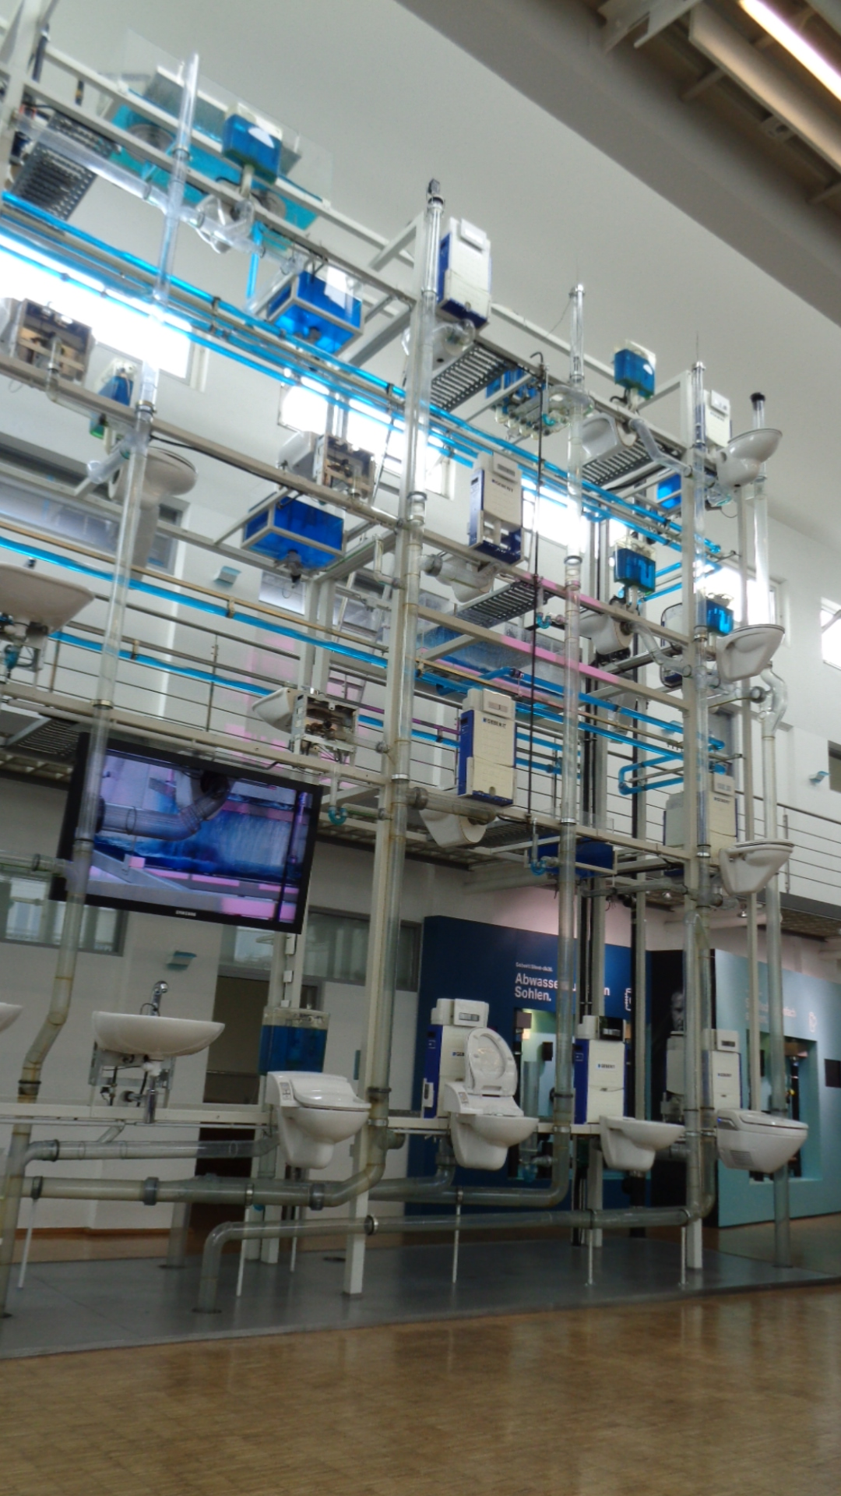

SECTION 1

Introduction

1.0.0 Introduction

The purpose of this document is to present to the World Plumbing Council and other interested readers a brief account of my observations and conclusions of the World Plumbing Council 2013 Education and Training Scholarship study/tour of Germany. It is presented in such a manner that it would contribute to the conversation on plumbing education and practice. It is hoped that it would be of interest to teachers and students of plumbing, vocational educators and administrators and perhaps people who just want to acquire general information about Germany’s plumbing education system from another perspective.
The tour was undertaken against the background of problems affecting plumbing education and training at a local vocational education and training institution, the National Apprenticeship Centre of Trinidad and Tobago. There is tacit acceptance among several local plumbing teachers that the problems at this institution seemed symptomatic of a more widespread manifestation in the local plumbing education environment. It is also set against the background of challenges affecting the plumbing industry generally in the country of Trinidad and Tobago where a critical shortage of skilled craft-persons exists as a result of the inability of the plumbing education system to satisfy this dire need. It is not difficult to figure out that in this setting the quality of workmanship many clients received would leave much to be desired.
The aim of the tour was to search for those factors that foster the growth and development of the vocational identity or plumbing identity in students as a predictor of their completing their training while in school and remaining with the vocation in the future. A problem-based approach was adopted to increase the tour relevance to local plumbing education and industry realities. This was a condition made clear by the awarding body World Plumbing Council for accepting the scholarship.
The document focuses initially on the issues affecting the Trinidad and Tobago plumbing education and training environment and its corollary effects upon the plumbing industry at large. Then it looks at the background scenes surround the German society (its people, history, economic performance, its short terms goals, its general and vocational education system) then asked specific questions about the German plumbing education and training milieu. Even as this renown plumbing education model is selected for analysis we are reminded that just as the two national backgrounds are poles apart historically and otherwise, so too are they different in occupational profile, qualification requirements and learning outcomes. Despite these obvious differences I’m strongly convinced that there are many useful aspects of their plumbing training approaches that can inform and enhance our local practice. It youth unemployment achievement bears this out.
The country has had one of the lowest rate of youth unemployment in Europe (roughly 7%) while at the same time more than 60% of its young people choose apprenticeship programs. This large percentage of young people into vocational training and low percentage of youth unemployment suggest that they experience low levels of youth drop out from vocational programs. What are the factors contributing to this is which I wish to find out. Another issue of interest to me was that generally German employees have some of the highest numbers of paid holidays among developed countries, yet it is one of the most industrious and wealthy countries in the world. Are they more efficient at work than any other nation, and, if so, what accounts for it? I took a cursory glance at their stature and recognized that they are physically normal; the average West Indian seemed a bit bigger than the average German. Observing them at work showed they do not work much faster than any other group of people although a deeper engagement seemed evident; but fewer of them are visible on job sites compared to back home, they seem glued to their tasks and appear to accomplish more in a shorter time frame. Why?

SECTION 2
Local Context

2.0.0 Introduction

The purpose of this section is to provide the reader with a basis for understanding the local plumbing education, training and industry situations to which the study/tour of Germany is seeking information to shed greater light on and to add/solicit possible solutions. Also provided are key objectives the tour must achieve both to guide the tour and for evaluating its success and the possible hindrances to the achievement of stated objectives.

2.1.0 Plumbing training and industry realities

This study/tour was undertaken as a broader search for plumbing excellence and meaning for new entrants into the plumbing community in Trinidad and Tobago. Currently, the country has embarked upon a developmental path that entails increasing levels of industrialization, social and personal wellbeing of its citizens couched in a goal to achieve developed nation status by the year 2020. This national project requires the urgency of a highly skilled and knowledgeable and committed workforce.
No where is this urgency gradually assuming crisis proportion than in the plumbing industry. Despite a tradition of training in several agencies, there is a critical shortage of this genre of skilled personnel and it is projected to continue into the future while the volume of work seemed to have increased exponentially. As if almost suddenly there has been an infusion of sophisticated tools, equipments, innovative piping and fitting materials, energy efficient systems with alternative sources of energy as a fundamental requirement, electronically operated plumbing fitting, fitment and fixtures, sophisticated water and wastewater treatment system, more stringent quality assurance requirement and higher ethical expectation in the plumbing industry.

2.2.0 Impact on industry

Already the combined impacts of these conditions upon industry are being felt. The Agency responsible for water and sewerage activities and licensing of plumbers has reported increasing incidences of faulty workmanship by clients and many of these incidences are of a serious nature.' In concern and in efforts geared at addressing these shortcomings the Agency has effected a review of the National Plumbing Code of Trinidad and Tobago to make it current with international best practices. Additionally, it subjected all licensed plumbers to extensive retraining and assessment by the National Training Agency. But while these interventions may have improved the performance of craft-persons especially the licensed ones, they do precious little in minimizing the shortage of skilled plumbing personnel now existing.

2.3.0 Realities in vocational schools

In vocational schools two realities were observed that were exacerbating the problem. Fewer new entrants were coming into the vocation and of those who entered, an uncomfortably large number were leaving without completing their training program. Whilst only marginal or no control could be exercised to improve total numbers of new entrants, much more could be done to shape those coming into the training environment. And, indeed, much was done including changes to existing curriculum, modernizing instructional and training environment, increasing teachers attending and completing vocational teacher training programs, even lowering the minimum age at which student enter the programs. However, these did not significantly improve course completion.
These developments were occurring in an environment where death and diseases and other less yet unheard of experiences resulting from water related activities are increasing, while the status and expectation of plumbers have been upgraded through designation by WHO, (2006) as guardian of the environment. If concerted efforts are not expended towards deepening the plumbing experience or direct it deeper into young aspirants’ personality, high attrition rates would continue, low interest without commitment to the values, beliefs and enduring practices of the trade would continue to be manifested, while for the more academically gifted students plumbing would become a transition point rather than a terminal experience, especially in the local context where education is virtually free up to university first degree level.

2.4.0 An identity approach

With this in mind, a literature search was undertaken along lines of 'how to strengthening conviction and commitment to craft practice,' in vocational education and training. An interesting study by Tanya Bretherton (2011) titled “The role of vocational education and training in workforce development: a story of conflicting expectations on how Vocational Education and Training (VET) can contribute to enhancing productivity and increase workforce participation” was found. The finding and an accompanying recommendation suggested that in occupational areas plagued with low employee retention and entry of new entrant that a “sense of vocation” approach be adopted. In this study the researcher makes the point that a sense of vocation emanating from a deep understanding and meaning of the work undertaken possesses the potential to cultivate interests and commitment while developing a sense of identity in workers ultimately impacting upon their decision to remain in the job.
But before a stable occupational identity can manifest itself in employees it must first be initiated and developed in them as learners. Once initiated the development process must continue until, at least, by the time of the completion of their respective study programs that identity should be sufficiently developed in training to facilitate smooth transition into the workplace. The extent to which this identity is developed within new entrants training manifests itself in terms of their interests, goals, attitudes commitment toward the particular vocation. Thus, the more authentic and real world the learning environment the more stable the identity foundation formed. Dropping out militate against this process often short-circuiting and frustrating the development of a stable vocational plumbing identity. A consequence of a short-circuited plumbing identity are individuals employed within the trade environment yet possess low commitment and more unlikely to maximize further educational opportunities to further develop the plumbing self and the vocation.

2.5.0 Theoretical underpinning

The idea of an identity originated with Swedish psychologist, Erick Erickson. In his conceptualization and development of human personality he saw a process that was not just purely psychological and operating solely within the individual's mind. To him human growth and development was also social, operating outside the mind as well, as the child respond to various cues from care-givers, parents, peers and siblings present. Further, these psychological and social processes are operating within a wider cultural environment within which the young individual is constantly adjusting. In time the individual’s thoughts, beliefs values and attitudes gradually come to reflect those of the society with which he interacts.
Erickson conception of human personality development toward identify formation proceeded through eight developmental stages. These stages are trust versus mistrust (infancy), autonomy versus shame (toddler), initiative versus guilt (the preschool years), industry versus inferiority (elementary school years), identity versus role diffusion (adolescence), intimacy versus isolation (young adult), generativity versus stagnation (middle age) and integration versus despair (retirement years). Each stage presents certain issues/tasks which the growing individual must confront and overcome if his development is to proceed normally and contribution to further development and socialization. The identity versus role diffusion stage represents that period when adolescents begin to think in terms of their place in society, adult roles and expectation, and the future roles they prefer to be identified with. It is also the period in which they are most susceptible to vocational influences and socialization. These stages can also be used to provide an understanding of how newcomers are eventually socialized into any vocation for that matter.
For a more thorough and encompassing understanding of human personality development and underlying structures Jean Piaget's stages of cognitive development and Lawrence Kohlberg’s theory of moral development can be consulted. It is also advisable to consult James Marcia’s work on the operationalization of identity. These theoretical frameworks are important, for too often, even among vocational education people vocational education is viewed solely in instrumental ways: as a tool to satisfy industry insatiable appetite for skilled labour. Too often vocational education is undertaken in a crude and depersonalized way without a knowledge of what it means to be a human person. More than this, the learning environment is adapted to conform to these skewed assumptions. However, as important as industry's needs are, education is primarily about identity formation (Wenger, 1998). If this is not the fundamental premise upon which vocational education stands it easily descends into an exercise in deep psychological provocation with not too pleasant consequences for both the individual and society.

2.6.0 Benefits of an identity approach

There are several benefits to be derived from adopting an identity approach to students' plumbing training. This approach can deepens training making it part of the new entrant personality enabling him/her to develop interests, values, beliefs and ultimately a commitment to the vocation. In the local plumbing context this is important where fewer new entrants are coming into the vocation and older workers are retiring it can build vocational commitment resulting in fewer wishing to leave. An identity approach can foster deeper ethical consciousness about the worth and values of plumbing to the society especially at a time when deaths and diseases and other less traumatic, but unheard of experiences resulting from water related activities are increasing. If concerted efforts are not expended toward deepening the plumbing training experiences directing it into young aspirants' personality as suggested by CeDefop (2009), there is all likelihood that high attrition rates would continue, low interests without commitment to the values, beliefs, and enduring practices the vocations cherishes, would continue. To some of the more academically gifted students plumbing may then become a transition point rather than a terminal lifelong experience. This is more so in the local context where education up to university level is virtually free. The consequences to the future viability of the 'beautiful trade' and the future of society demand that every avenue be explored, at least, to retain every student who initially enters the plumbing training environment.

2.7.0 Study/tour purpose

Germany is an amazing country whose people seem to have a very resilient spirit as a national defining character that allows them to dig deep into their spirits and their collectivities to tap into wellspring of energy and sustenance especially in periods of disaster. After the debacle of two consecutive world war which decimated the country's social and economic infrastructure, that country without much natural resources rebounded to become one of the more prosperous country in Europe today. This achievement of prosperity is even more remarkable when it is considered that Germany has more paid public holiday than other developed countries. A main contributor to this outstanding achievement is undoubtedly its famed vocational training tradition. With its infrastructure in disarray it quickly harnessed what was salvageable from its glorious education and training tradition, and, even in a crisis it never failed to deliver on expectation. A notable feature of this resurgence is its ability to harness the energies of young adolescents and direct it to productive endeavours contributing to the country having one of the lowest rates of youth unemployment in the world.
The purpose of this study/tour therefore was to tap into the reality of this enduring German education and training tradition to understand its deeper philosophical, theoretical, structural and operational underpinnings and how it contributes to maintaining low attrition rates, while seemingly keeping new entrants interested, goal focused and committed to the vocation, in pursuit of wellbeing for all. Information gathered in the German context can assist in shedding light on, among other things how vocational identities are formed in the vocational arena and in the plumbing vocation in particular.

2.8.0 Study/tour goals and objectives

The overarching goal driving this study was the development of a comprehensive understanding of Germany's vocational education and training system and how it contributes to identity formation and promotes reduced levels of drop outs in the plumbing context. The tour objectives were to:
- identity the theoretical foundation underpinning Germanys vocational education
and training system with reference to the plumbing trade;
- observe the operation of Germany's vocational education system and its ability to build critical consciousness that facilitates smooth transition from schools to the workplace;
- determine the nature of the relationship between the country's school system and workplace;
- identify how the workplace contributes to the development of the peculiar plumbing identity/ personality;
- identify features critical to selection of students for the plumbing vocation;
- discuss with plumbing training personnel the features emphasized in their training;
- draw conclusion about the capacity of their plumbing training system to contribute to plumbing identity formation; and
- observe provision made to facilitate young people entry into the workplace.
In addition to previously stated objectives the tour was guided by several questions whose answers shed light on the German plumbing education and training context to minimize dropouts, to keep apprentices interested, goal centred, foster smooth transition between school and the workplace and once there to make long-term commitment to the vocation. These issues are closely related to the formation of students’ vocational plumbing identity and how it is initiated and sustained in the learning environment. Invariably these questions influenced the type of institutions visited and the nature of the discussions entered upon with students, plumbing teachers, masters and administrative official. Some of the original questions were changed and modified in light of information obtained during the many visits to teaching institution, industry and research environment.

2.9.0 Questions guiding the tour

The following are the questions for which answers were sought.
- What philosophy underpinned Germany's vocational education and training system in particularly the plumbing training?
- What is the nature of the governance structure for plumbing education and training experiences in Germany?
- What the pedagogies at work in Germany's plumbing education?
- What roles do workplaces play in the formation of the plumbing identity and what legislative agenda governs the relationship with plumbing training in workplaces?
- Is the German plumbing education program identity focus?
- What incentives attract and sustain plumbing students' interests over the course of their training?
- What personality type is the German plumbing education tending to produce?
- What special orientation process initiates young plumbing aspirants into the community of plumbers?
- How does sustainable health and environmental issues integrate into the plumbing training students receive?

2.9.1 Sites observed

Several sites were visited during the five weeks scholarship period to provide answers to the previously mentioned questions which purposefully are aligned with the tour key objectives, but more so to provide pictorial evidence of the structures of the German education system and to emotionally engaged the tour. These sites were carefully chosen by the German Plumbing Heating and Air Conditioning Association (Zentralverband Sanitar, Heizung Klima) vocational education specialist in close consultation (the Germans capacity for consultation with me was immaculate before the tour began, during and after the study/tour). They involved visits to primary schools, secondary schools, plumbing guilds, Chamber of craft training, technical colleges, technical university, publishers, workplaces, manufacturing establishments for plumbing\and goods and research institutions. These institutions were scattered throughout Bonn, Cologne, Bavaria, Stuttgart, Berlin, Frederichstaffen and Arnsberg and demonstrated the pervasiveness of the plumbing training culture.

2.9.2 Methodology
This study/tour adopted a simple methodology. It used general observations of the sites visited, asked simple questions of teachers, students and some administrators supported by the literature received from the institutions visited to draw broad conclusion that were more informative than instructive. From the sample of institution provided and visited the aim was to form as clear a picture as possible of the nature of the German plumbing education system and its ability to keep students interested and goal oriented during training and to make predictive statements about their likely future involvement with the vocation.

2.9.3 Limitation

Several limitations dodge this tour. First, was the inability of the scholar to communicate with natives in the native tongue. This made communication with plumbing students and plumbing teachers in those institutions very elementary at best. Another limitation has to deal with books. Secondly, all of the books used in plumbing classrooms were written in German. This means that the researcher encountered difficulty perusing much technical literature including curriculum document. Finally, the size of the sample institutions provided limited the sweeping type of conclusions that could be drawn from the findings. Thus when the term German or Germany’s vocational education or plumbing education is used in this document it is used in terms of the sample provided. But personally, the high standards and qualities of tools, equipment and machinery observed both in plumbing heating and air-conditioning as well as in other trades as well as the competition among vocational providers for young people to train have convinced me that these standards and qualities are the morn in training. However, caution must be exercise when generalizations are to be made.

SECTION 3

Germany at a glance

3.0.0 Introduction

This section attempts to provide a quick overview of this lovely country, Germany. It would look at the physical features of the country, people and population characteristics, economic activities, short history, education and vocational culture and the importance of plumbing to that country.

3.1.0 Physical features
Germany is a relatively large country situated in central and Western Europe consisting of 357, 022 square kilometres. It shares common borders with several countries including France, Netherlands, Belgium and Poland. The climate can be described as cool with wet winters and mild to hot summers. Generally, the temperature range from between minus two to about 25 degrees year round with lengthy overcast conditions whose weather conditions can to change rapidly. Whether seen from the sky or while passing on trains this country's landscape is beautiful to behold: clean flowing rivers and lakes interspersed among green gently rolling hills and valleys, dotted with manicured forests and colourful vegetated plains gradually building up to the mighty snow-capped Alps makes the physical environment a fairytale experience. Sunny days can really intensify this experience and heighten the tranquilizing effects upon visitors mind.

3.2.0. Politics
Germany is a Federal Republic. The Preamble to its Basic Law declares that it is a Social Democratic Republic where it people are called upon to achieve self determination, the freedom and unity of the country. Social Democratic is an approach which incorporates capitalist and socialist practices to ensure economic growth and a fair distribution of wealth and income in pursuit of peace and wellbeing for all.

3.2.0 Population
Germany has a population of approximately 82.3 million, which is made up of 95% Germans, 2.3% Turks, 1.7% Italian Polish, Greek and Yugoslavian refugee make up the remainder. As of 2012, 13% of the population was under 15 years old while 53% were 60 years and over. Women are marginally more represented than men. The country has one of the lowest annual population growth rate of -0.2 in the world and the general feeling is that if efforts are not expended to enhance this important statistic there can be undesirable consequences upon its sovereignty and economic wellbeing.

3.3.0 Natural resources
Several naturally occurring resources can be found in the country. Among them are iron ores, coals, lignite, natural gas, copper nickel, uranium, potash, salt, construction material, timber and arable lands. These base material and others imported, contribute to a range of industrial activities including chemical, plastic production, machinery, vehicles, machine tools, electronics, food and beverage, shipbuilding, space and aircraft, optical and medical equipment, pharmaceuticals, textiles and agriculture. These formed the basis of the national economy paving the way for booming economic activities. Germany is the fifth most industrialized country in the world manufacturing goods and services worth 3.87 trillion dollars.
3.4.0 Prosperity and wellbeing
Germany is generally considered by most measure a prosperous country today and this has been the case for the last decade with stable improvement over the last five years. Few of its neighbours can be compared with it on several indices including the economy, entrepreneurship and opportunity, governance, education, health, safety and security and personal freedom. According to the Legatum Institute (2013) which uses these measures rather than the GDP as a measure of prosperity, Germany is ranked as the fourteenth most prosperous country in the world. In surveys done between 2010 and 2013 and reported by this institution in 2013 it was found that the capital per worker is 124,709 USD: this is significant when it is considered that the global average is 47, 604 USD. 98% of the population is satisfied with the standard of living, 96% of the nation has access to good drinking water. Even ethnic minorities (82%) and immigrants (83%) expressed their confidence that the country is a very good place to live and make a living.
Although trust in people is somewhat low and approximating that of church attendance given the nation protestant traditions the social and charitable spirit of the people still lives on. For example, people still donate money to charity, marriage is still a valued tradition and friends and family can still be relied upon in time of needs and distress, the Legatum Report concludes. It must be noted that in all cases the local averages exceeded the global average and significantly so in several cases.

3.5.0 Brief history
The rich and prosperous country also known as Deutschland today did not emerged from a people with common ancestry and ethnicity. Neither has the relative peaceful social environment which now prevail an indication of sustainable historical trends. According to the American Library of Congress (2014) the Germanic tribe came from several mixtures of people from along the Baltic Sea coast who occupied the northern region of the European Continent. With time as they move inward towards the central and southern parts of the country the group expanded as they either negotiated peaceful existence and integrated other vulnerable groups or through aggressive types of engagements, groups unresponsive to their rampaging tendencies were subdued and integrated. As settlement gradually stabilized the efforts of major groups became characterized by ever evolving efforts at bringing hundreds of small groups, small states, duchies, principalities, free cities and ecclesiastical states under one rule.
In medieval Europe towards the Middle Ages assemblies of disparate entities made attempts at nation building a difficult preposition. Long periods of war among local rulers were very common. Not even the mighty Romans with global control in view were able to integrate these entities into a sovereign state with common interests. In fact, the general beliefs is that the fall of the Roman empire was greatly influenced by this marauding and adventurous people that repelled their incursion northward on several occasions (Matthews and DeWitt Platt, 2004). The protestant reaction against Papal domination did little in this respect but served only to complicate efforts at national building.
Some semblance of unity among warring groups came through the Habsburg Dynasty. The peace of Westphalia in 1648 gave an appearance of further unifying the Germanic speaking people but what it ultimately did was further divide them into hundreds of smaller states. Much of the jockeying for unity came from major states like Austria and Prussia with interest to gain. Smaller states made alignment as it was advantageous to their cause and existence. By around the 1800's the unification call became more intense and from a wider group of business people, students, journalist, scholars and bureaucrats. And even this widening appeal was thwarted because some rulers perceived that this process would result in some measure of power loss. However, the call for unity prevailed.
But the search for peace in any age is an eternal striving and a conquest of the human spirits and the drive for unification prevailed in 1871 following the German-Franco war under Emperor Wilhelm I King of Prussia. Building on this foundation Otto von Bismarck in what was described as “masterful diplomatic manoeuvres and three brief and dazzlingly successful military campaigns” was able to consolidate previous gains and usher in real unification and democratic practices.
Even this partial unification victory failed to subdue the restive German spirit for the unification of all German speaking people where-ever they are situated, and greater influence on the European continent. Two costly military escapades (World War I and II in 1915- 1920 and 1940 - 1945) all geared toward territorial and economic expansion left Europe in disarray with the loss of millions of lives. A major consequence of this rendezvous resulted in the country being divided and governed by victorious allied partners namely US, UK, France and the USSR. This meant that the country was divided not only geographically but ideologically as well. Western countries subscribe to a more democratic approach to governance while the USSR embraced a socialist ideology. These differing political views of people and society and their relationship to each other has greatly influenced the country's rate of recovery. In just twenty years, the western part of the country has rebounded from these debacles and rebuilt its social and economic infrastructure, whilst the socialist entity lagged quite noticeably behind.
On the surface this remarkable recovery makes statements concerning the democratic ideals and the economic assistance provided by victorious western countries. But as is evident with many nations in similar position that never truly recovered from such national disaster, much more than pecuniary assistance are required. But more can be gleamed from this extraordinary achievement. In a sense it points to the collective will of a people to dig deep, to endure deprivation and intolerable hardship the resilience of the German spirit to overcome, a feature that may have developed earlier during its nation building stage. It also makes statements of the enduring nature of its education and training foundations and the system’s ability to build people in periods of adversity whether formally or informally.
When these features become recurring experiences in a people's existence a peculiar character is formed and a peculiar consciousness is developed. Looking at the complex and enriched nature of German vocational training environment one is convinced that it aims is to build just these capacities in young people. Additionally, a history of compromise, wielding and dealing among disparate entities en-route to nationhood has forged and refined another important ability. The art of negotiation, the ability to discuss, a search for consensus was etched into the national psyche. This ability has been extensively used and proven beneficial to national interests. Over time, it has become an important decision making tool and stated policy mandating, that the social partners labour, management and government must come together and arrived at conclusions. Once agreement has been reached the final decision is bind upon all. Finally, operating as small states with threatening external environment has forged special mental aptitude that fostered a spirit of thrift, conservation and to make do with little has becomes a defining character contributing to national wellbeing and prosperity.
3.6.0 Future ambitions
Today, with the past painfully etched upon their consciousness Germany is united politically, geographically and enjoying unparallel level of economic prosperity and wellbeing. A concern engaging policymakers is how to ensure that this social and economic prosperity become sustainable for future generation. As an export oriented nation one thing it is well aware of is that such goal cannot be achieved without peaceful co-existence with neighbours and not just neighbours but prosperous ones as well. To this end Germany has played important roles in the cooperative efforts leading to the formation of the European Union. It is one of the leading donor countries in the world contributing approximately 13 billion dollars annually towards not just European but to the world in general. But there is concern that this spirit of liberality and the reduction of its sovereignty in shoring up the Union can exert a destabilizing effect upon its most famous product: by making concession with its high vocational standards to accommodate its neighbours can lead to a watering down of the famed apprenticeship education and training system.

3.7.0 Importance of plumbing
From the time Neanderthal man ceased his roaming ways to promote more stable living two issues became very important. The first was how to acquire an adequate supply of portable water for the daily needs of each member of the community. Good drinking water – the essence of the plumbing trade – is important to life. Without it life is just not worth living, there is no life at all. The second was how to remove the waste generated through human activities especially those of an organic nature. These issues have been the concerns of mankind from time immemorial. How they were addressed determined in large measure the quality of life citizens experienced. Archaeological findings from ancient Egypt, Babylon, Greece and Rome have all brought back stark reminders of the importance of plumbing to those civilizations and despite the passage of time the importance of plumbing has not been reduced in value or worth.
Failure to deal with these twin issues has had serious consequences on both nation and people. For example, the Black Death, bubonic plague which decimated almost one third of the European population during the 1300’s was greatly influenced by the society inability to deal adequately with the issues which surround water supply and waste removal. On the other hand when these issues were adequately dealt with the economic, psychological, social and physical health of people improves and society flourished.
It was from these initial historical concerns that plumbing importance grew. When, afterwards the need to provide central heating in building to compensate for the harsh and unforgiving German seasonal weather, plumbing’s importance took a quantum leap. Germany has more building than people. Almost all these structures require some form of water use activity whilst all may require some form of heating for normal occupancy. Additionally, in 2006 the World Health Organization recognizing the importance of good plumbing to health and wellbeing, has designated the plumber as “the guardian of the environment.” – Air, water and land. This has indeed extended the role of plumbers in several tangible.

3.8.0 Good drinking water
But the essence of the plumbing trade is the supply of good drinking water. Adequate supplies of it make significant contribution to not only industrial productivity but primarily to human health. Such is the importance paid to this commodity today that the United Nation Secretary General has elevated access to safe drinking water as a fundamental human need and therefore it constitutes a basic human right (UNDP, 2006). For countless people the world over particularly from Least Developed Countries a reasonable daily supply of water is a frighteningly scarce commodity. According to WHO (2006), “Inadequate supplies of this commodity has resulted in approximately 3.1 million people dying annually with the majority being children under five years old. What is not reported are the countless survivors who have endured pain and agony brought about in some way by this inadequacy. To these drawbacks can also be added the millions of school age children who cannot attend school due primarily to their daily search for this precious commodity. This international Agency went on to say that “these rights are not optional extras, nor are they voluntary legal provision to be abandon at the whims and fancies of individual government.” He concluded that they are binding obligations that reflect universal values and entailed responsibilities on the part of Government UNDP, 2006). In this regard, it’s a credit to current World Plumbing Council Chairman Sudhakaran Nair for his vision in addressing this critical need of least developed countries by making available a special plumbing scholarship to this group of countries. In doing so, the plumbing benefits enjoyed by developed and developing countries are also made available to those needing it the most – least developed countries.
Generally, people consume water in several ways. These may include uses for personal hygiene, toilet flushing, dishwashing, drinking and cooking and for other purposes (European Environmental Agency, 2006). Excessive use may result in water problems such as low river flow, water shortages, salinization of freshwater bodies in coastal regions, human health problems, loss of wetlands, desertification, and reduction in food production. Although Germany is blessed with an abundance of clean clear water both above and below ground it issues may not mirror those of least developed countries.
If access to water is a fundamental human right then nature has established this as facts in Germany. Unlike Sub-Sahara countries the country is awash with water. Traversing through the land and visible to the eyes are rivers, lakes and other sources of clean surface water replenished annually by a predictable hydrological cycle. From high up in the Swiss and Austrian Alps come streams flowing into Lake Constance there to begin a long journey to the North Sea through France and the Netherlands as the Rhine. Here water is used in addition to previously listed as means of transportation, sport and leisure commercial and agricultural purposes. Germany’s annual water needs amounts to approximately 183 billion cubic metre of water. But water is a finite resource and requires strict management if availability is to be sustainable now and in the future.
Although Germany does not have problems with limited water supply and although it appears to use frugally what it consumes, it does have water related concerns. Obtaining water from source particularly from underground sources, transporting it to water treatment facility, treating it and distributing requires energy. Primary sources of energy in the local context are imported oil, gas and local coals. These supply roughly about 70% of the country’s total energy needs. Using fossil fuel exacerbate environmental pollution. When fossil fuel is burnt the end product is carbon dioxide and water. Last year the country produced 951 million tons of green house gases. Carbon emission is reported to significantly affect the atmosphere leading to ozone layer depletion and climate change. As climate change increases there is increase in the warming of the atmosphere. This in turn can significantly alter the hydrological cycle with modification to the timing, volume and intensity of precipitation, the flow of water in watershed as well as the quality of aquatic and marine life (USEPA, 2013).
Thus, from a water standpoint Germany can become a major contributor to environmental degradation. As a consequence plumbers are increasingly being called upon to select and install water systems that reduce water use where necessary and contribute to the protection of the environment. The call will become even louder as the country industrialization improves.

3.9.0 Education system
A major issue occupy the attention of policymakers is how to perpetuate these advantages. In other words how to ensure that current benefits (national wealth and wellbeing) are pass down for the enjoyment of future generations. Increasingly, education and skilled development of citizens is viewed as pivotal in this regard. The literature is replete with research showing the relationship between economic wellbeing and increasing educational opportunities and skill development. A casual observation would show that as individuals' educational attainment increases so do their economic fortunes and this is true for almost every county in the world. Similarly, greater access to skill development centres also increases the potential of individuals to experience enhanced economic growth and personal well-being.
Although, today, the country is served by a constellation of institutions all synchronized to rapidly respond to its citizens' educational needs the foundation did not happen overnight. Germany has had a relatively long history in education. And even though it begun taking shape around 1700's had it roots in medieval Europe.

3.9.1. Medieval academic education
Medieval education closely followed the Christian tradition and embraced an 'other worldly' perspective of things. They envisaged reality as determined in the heavenly with man having little or no say neither in his own destiny nor in the affairs of the cosmos. They viewed knowledge as essentially gained through transcendence while the nature of man was viewed as naturally sinful, helpless and wretched. The church was seen as the guardian of knowledge and priests, standing in God's place, to dispense not only knowledge but justice and mercy as well. Therefore, what was known as academic education in its elementary aspects consisted in an education just for enabling bible reading, while the higher form followed the classical order enunciated by Plato. This generally consisted of the trivium (logic, grammar and rhetoric) or the quadrivium (arithmetic, astronomy geometry and music). Women were generally excluded and mostly men were involved in these academic endeavours while classes were generally held within monastic or cathedral schools. This form of education lacked a defining purpose other than to prepare the nobility for the bureaucracy, the priesthood and to a lesser extent the military. With these perceptions engrained in the consciousness of people many did not have the mental aptitude, the strength, the determination to alter their lot in life and resigned to the status quo of servitude, serfdom and misery. With slight improvement this educational state continued until well into the 1700's.

3.9.2. Medieval vocational training
During the same period and side by side with the nobility, a priest and warrior class for which education was of vital importance was the artisan class. This group consisted of skilled individuals who owned tools and performed skilled work in a specific area and bounded by common law (Epstein1991). This group of craft persons produced a wide variety of products which lead to increasing wealth and wellbeing of both craft persons and country. According to Matthew and Platt (2004) through the work which they performed and the relevance of these skills, artisans grew in importance to become influential persons in society. Over time groups of likeminded individuals similar industry skills came together and form more powerful organizations.

3.9.3. Medieval guilds
One such organization of craft-persons was the guilds of crafts. Even then guilds made significant contribution to the German's production and economic system by creating products known for quality and durability. Further, at a time when social life in Europe was turmoil due to the collapse of the mighty Roman Empire and the processes for seamlessly socializing the young into society's norms in disarray, these guilds played important roles in socializing young men into society's expectation. Epstein (1991) is of the view that guilds, known by the Romans as collegiums were in existence since the Greek civilization. In Roman time they got their existence by petitioning the emperor for legal recognition.
Guilds usually have a customary structure and common functions. They were headed by masters with several young men apprentice to them from which over a period of five to seven year they would acquire the skills, attitude, knowledge and standards common to that occupation. After the period of apprenticeship many of these now trained individuals choose to either remain with the master to develop the guilds whilst other would be free to leave and practice their recently gotten craft by journeying to various villages plying their trade or just enjoy their new found freedom.

3.9.4. Functions of guilds
Guilds carried out other primary functions in addition to education. Often these guilds operate in ways which assist in protecting the livelihood or interests and other conditions seen as necessary for the sustainability of peculiar vocation. They set prices for units and for commodities; they legislated standards of quality; they established business customs to suits their individual needs, and they admit to train those more likely to uphold their rules (Godt, 2003).
Although they could not match the recognition afforded by the nobility and military guilds were able to provide social and economic status for craft-persons as an alternative to the drudgery of agriculture and domestic work. As their numbers, worth and value grew, some guilds masters yielded such social power and authority that many got involved in the political and legislative process of towns. This political affiliation allowed many of them the opportunity to set conditions in place to extend the existence of the guilds themselves (Godt, 2003). This state of affair continued until well into the 1500's despite the upheaval occurring on the European continent as the classical foundations of thought underwent explosive change.
In Germany during the 1800's unlike countries like England and France who modified vocational education to meet the demand of the industrial revolution, the traditional method of apprenticeship training in place since the middle age continued. In large measure this position ensured that the craft sector, small shopkeepers and small farmers’ interests were not gobbled up by large establishment. A major outcome of this position was that it gave greater control of trade related matter especially trade examination, to trade corporation or guilds (Cedefop, 2011).
In the 1900's the general aim and objectives primarily was to broaden schools' participation in the vocational education process to meet industry's needs for skilled labour. The influence of guilds diminished accordingly as more powerful organizations arose usurping responsibilities formerly accorded guild and addressing challenges guilds were too inelastic to respond to.

3.9.5 General education
Around the 1700's century Europe went through a period of religious, social, and ideological turmoil that set in motion new ways of seeing reality and human nature. The northern Italian recognizing the lack of growth in almost every area of human endeavour over time, despite what was promised, reverted to their rich past. And in what was salvaged from classical philosophy, architecture, sculpturing, painting and poetry they found glorious inspiration to move forward embracing humanism in the process. Armed then with more scientific and realistic methods of determining reality, they subjected almost every classical idea underpinning much of European thoughts to scientific questioning.
From this tumultuous explosion occurring in the Europe, came changing notions of not only the nature of the cosmos, but also what is reality, the conception of knowledge and the nature of man. A major turning point in this revolution of ideas, for example, was the view that the planets in our solar system including the sun evolved around our earth. Once this unproven yet widely accepted idea was proven to be false and replaced by the reality of the sun as the centre of the solar system, instead, the floodgates of change were opened to the classical explanation to the nature of things (Matthew and Platt, 2004). These three domains, the nature of reality, the conception of knowledge and the nature of man are very important to any educational enterprise and it is vitally necessary that their essence is understood. Despite being at the forefront of the reformation movement from a Roman to a Protestant position Germany soon adopted the humanist approach.
Typical of the ancient Greek and Roman civilization modern humanist's endowed man with more enabling and enterprising qualities. He is now seen as endowed with beauty, worth and dignity with a capacity to learn, create and enjoy; was conceptualized as rational and capable of logical reasoning. Later, to enhanced his existence, through Locke, he was endowed with inalienable rights which cannot be easily be abrogated and it is these rights which defined him a human being. He is capable of development with capacities to determine his purpose, meaning, the nature of the universe and the mystery of life itself. Without these noble expectations, their scope and the enabling environment to become thus, he can descend into anarchy becoming more savage than the brute best.
These new ideas sprouted changes everywhere. Education itself underwent change. No longer was it viewed as the domain of the rich and powerful, rather, it was seen a process for harmoniously developing not just the mental and physical but the entire being, and school in particular were seen as process for shaping virtues through activities that are practical and attitude forming, and sensory. The nature of the child came up for review too. The prevailing child depravity theory came under question. This theory held that children are born naturally evil and that punishment by teachers to enforced discipline is inherently appropriate. However, from Pestalazzi, Rousseau, Locke among others, this idea was replaced with a more optimistic view of children as beings with unlimited potential for development. They learn through playful episodes in environments that are as natural as possible. And while humanistic ideas have influenced kindergarten school organization and administration they were soon to exert a dominant influence upon the nature, content and structure of general education.

3.9.6 Structure and nature of schooling
To transmit its unique culture Germany employed probably one of the most complex and sometime confusing (for people like me) education system on earth. The structure begin unofficially with kindergarten that is operated by private interest including churches, into primary and an array of secondary and vocational schools, into within firms and workplaces then to tertiary and university and further education classes. The goal is clear: to offer young people a comprehensive range of education that enable them to seamlessly find their individual paths into the world of work in the shortest time possible. The primary sub-system seemed to be universal while the secondary education sub-system is seemed tailored specifically to the country peculiar needs. The aim of primary education seemed to provide children with the skills and attitude in preparation for secondary education. Secondary schools sole purpose of secondary education is to prepared students for either further secondary or the vocational experience.

3.9.7 Pre-school
Typically, from between three to six years children attend kindergarten school prepares them for the next stage. However, attendance here is not compulsory. Many primary school teachers who interface with children without such preliminary exposure think they should as it ensures that basic numeracy and literacy as well as other school dependant attitude particularly the social skills are acquired. Their activities here consist in manipulating cube shaped objects, playing and investigating theme consistent with their developmental stage and growing interests.

3.9.8 Primary school (Grundschule)
Primary schools are the first school stage for German children. Unlike kindergarten/preschool this stage is compulsory for all students. The aim purpose of this stage although variable changing depending the lander/county generally is primarily about preparing students for lifelong learning and living in the modern world. For the next four to six years depending on the lander students would be exposed to several subjects including maths, reading, writing, science, art, geography, local history, sports, religious knowledge or ethics depending on whether parents object to religious instructions.
At the primary school visited a cooperative teaching methods was observed. The class explored a topic in the daily newspapers suggested the teaching methodology is one that builds on students personal experiences through probing questions. This was the method generally observed in colleges and guilds.
Assessment of students' performance is monitored continuously and based on the knowledge, abilities and skill achieved in class. Movement through the grades are achieved by yearly subject teacher reports. No examination is required at the end of primary school period. The last school year report, subject teacher's assessment of students ability normally determines not just entry into the secondary level but also which of the different type of schools students access. In a sense even this process of leaving the primary school can be classified as a streaming process because, by and large, it separates the primary school leaving cohort into ability groupings suggesting who occupy further academic schools, those more likely to proceed into the vocational tract and those requiring remediation.

3.9.9 Secondary school
Several secondary school types are available to students coming from primary schools. The main aim of these schools is to prepare students either for higher education entrance qualification, or for vocational qualification and the world of work. Which one a student is finally assigned depends on his primary school academic performance and would engage students' attention for the next five to eight years. The most sought-after class of secondary school appears to be the gymnasium and placement here usually results from exceptional primary school performances. The general focus evolved around in-depth knowledge, skill and competence in mathematics, modern language, classical language and natural science. They promote and strengthen the development of personality, the shaping of responsibility and participation in the democratic society (Germany Ministry of Education, 2013). These academically oriented schools generally comprised an additional two years of schooling geared towards taking successful students through to university.
On the preferential secondary school list intermediate schools (realschule) stand next in German pecking order. From grade five to eleven these schools progressively exposed students with the standard academic subjects of maths, language, economic, science, social studies that is less intense than the gymnasium. The general trajectory of these programs is entry into the vocational tract and ultimately the world of work. At the end of 10/11 grade successful students are awarded the Realschule Certificate guaranteeing fulltime attendance at vocational school.
Following realschule on the preferential list are the secondary general schools (hauptschulen). From grade five to ten (10 – 15 years) they engage students in subject ranging from language, math, science, social studies, arts, religion, music and activities providing exposure into the world of work. Together both types of schools curriculum appear more vocationally oriented as the vast majority of student leaving these schools eventually enter apprenticeship and vocational secondary schools. By as much as two years into their respective five year academic program vocational exposure is made available to some students showing a distaste for or who are not challenged by the academic program.
There are other types of general secondary school in Germany. In some landers realschule and hauptschule are gradually being replaced by comprehensive school (Gesamtschule). This type contains all the beneficial elements of the gymnasium, realschule and hauptschue. There are also special types of school normally for students with disability and like the realschule they generally promote early vocational arousal and socialization.
The German education system is notorious for the efficiency with which young people are channelled into various vocational streams. For students pursuing work-based programs entry can commence as early as age fifteen in hauptschule, realschule and gesamtschule. Students attending gymnasium with interest in these programs generally cannot enjoy this facility and must start their vocational program around 18 years at the completion of schooling. This is so because these institutions do not normally carry such programs or lack the facilities to do so.
Although it might have been noted earlier, a point needs to be emphasized here. The structure and contents of the German education system is not cast in concrete. There are slight variations to this basic format. The Federal Government set the general educational system framework but it is the lander responsibility to carry out this framework taking into consideration factors peculiar to their local context.

3.9.9.0 The dual system
For students with vocational leanings three approaches to vocational education are available and a variety of vocational schools setting provide opportunities for their’ preparation for the world of work. For those still with passion and high interests in school based approaches to learning there are fulltime vocational schools. For those not challenged by the school approaches companies training facilities provide in-company training without school involvement and many of these exist as complete alternatives to the traditional school system. However, the vast majority of young people prefer workplace engagement with some form of schooling and many schools operate on this basis to accommodate them. This division is based on the age old philosophy that the workplace constitutes the best place for practical learning, while schools constitute the best location for theoretical learning.
This is the system for which Germany is synonymous with and for which it has become famous. In spite of its patents and inventions the dual system is more famous and sought after than the country’s university tertiary system. This is the system that is even more famous than Mercedes or Bayer or BASP and for which the world is anxiously peeping into.
Generally the dual system begins partitioning within some secondary school system as the program begin to separate between academic and vocational, and within each vocational program the curriculum becomes dualled as the theoretical aspects remain in schools and practical features are directed towards the workplace. A main advantage of the dual system is that the real curriculum is essentially determined by the workplace in the workplace and therefore it is always relevant. In many cases innovative technologies are caught by students in the workplaces long before these technologies actually show up on written vocational curriculum document. Additionally, there are 1-2 years full-time vocational schools; there are advance vocational school 1 – 3 years; upper secondary vocational school 2 years; upper secondary vocational school 3 years; senior vocational school of 1 – 2 year duration. There are also chambers, guilds, in-firm training facilities as well as facilities for students with special needs. To this list of vocational schools can be added technical colleges and technical universities offering degree studies.
For plumbing heating and air-conditioning journeyman programs are done at vocational school and colleges. Some fulltime schools carry an additional one year training leading to the plumbing master qualification. Many guilds and chambers training facilities have programs up to the master’s level. The master’s program contains four part namely practice, theory, economics, law and pedagogy relating to the vocation and prepares students for higher level training programs, entry into teaching and opened up opportunities for self employment and to promote opportunities for lifelong education. Together, these institutions operate to ensure that transition period between school and workplace proceeds as smoothly as possible contributing to the lowest rate of youth employment anywhere in the world and to ensure that the German economic machine keep running.
A point to note here is that although the system is basically dual it must not be inferred that once you’re in a vocational or academic track that’s your final destiny which, of course, is the ultimate aim. The system is flexible with avenues for vocational students to re-enter academic program and for academic students to enter vocational track. In fact many academic oriented students eventually find their way into the vocation and add to the prestige accorded German vocational programs. A classical case has been a prolific writer I met at one of the publishing houses though with degree in literature his background was traceable to an apprenticeship in joinery.
Generally, students in the dual system must sign an apprenticeship agreement as a condition of their acceptance by selected firm. This agreement spells out the responsibilities of both students and firm and binds both parties to the conditions of the agreement and only through arbitration can such contract be broken. Duration of training, contents to be learnt, holidays and special days off and weekly pay rates are some features contained in the agreement.

SECTION 4

Findings

4.0.0 Introduction

This section deals with the answers provided in response to the main questions guiding the tour. These questions are also in line with the tour’s main objectives. While some answers came from students, teachers and administrators others came from my observations, assessment and validated by some of the literature provided by various institutions. The aim was to acquire a deeper understanding of how this country’s vocational training program contributed to students remain goal oriented, vocation focussed in training and ultimately forming long term commitment to the plumbing vocation. In other words how their plumbing identity is shaped.

4.1.0 What philosophy underpinned Germany's vocational education and training
system in particularly the plumbing training?
With some of the institutions visited the ideas of an overarching philosophy, could not be specifically pointed although they were generally aware of the leading role it serves. The often heard expression was that ‘the system evolved over hundreds of years.’ However, there were certain issues respondents were very clear about. They were very clear about the role of schools; meisters and the importance of the workplace as the ideal location for young aspirants to engage the vocation acquire trade knowledge, skills and attitude. As the teacher from Robert Mayer Schule reiterated, “if you want to teach a man to swim you need to go into the water,” in summing their practical philosophy to vocational education.
Apart from the tangible things, workplaces contain many trade secrets that cannot be express in writing or reified into curriculum document. Etienne Wenger (1998) refers to these as the implicit relations, tacit conventions, subtle cues, untold rules of thumb, recognizable intuitions, specific perceptions, well-tuned sensitivities, embodies understandings, underlying assumption and shared world views. These can only be caught through close observation and are very important to the formation of any enduring connection and identification with the vocation.
Secondly, the German plumbing education system recognizes the primacy of the meister/master as the standard requirement for teaching and ensures that this level of expertise becomes the lowest point at which newcomers engage the vocation in schools and workplaces. All plumbing teachers were duly qualified and experienced masters with pedagogical skills as well. Furthermore, as teachers it was not enough for these individuals to be just qualified and experienced master plumbers, they must also have first internalized then to model those plumbing values and behaviour they want students to imitate.
In addition it is also noteworthy that a large number of meisters were also owners of registered plumbing, heating and air-conditioning companies. This serves an important function. As these meisters sought to make their companies more efficient especially when undertaking further training, they would also be making contribution to the vocation development as well. The several jobsites, Guild at Schwienfurt and Cologne, Cologne Chamber of Craft and vocational colleges visited the master was most evident and the apprentice within scaffolding proximity.
Accordingly, despite being unable to express a definite philosophical framework supporting the plumbing education system the basic tenets of such a framework was not difficult to discern. Humanist traditions still pervade with learners and their interests as natural starting points; students viewed as active learners; teachers as models guides advisors rather than directors; classroom activities focus around problem solving; the social atmosphere being cooperative and democratic and the school seen as a miniature society. These ideas were gradually being integrated with social influences consistent with the nation’s social democratic political aspirations.
However, the notion of apprentices’ emersion into workplaces and engaging the master (knowledgeable other) fits into a wider socio-cultural framework. Essentially this framework views humans as social being, that learning is a social process, and the best form of learning occurs through newcomers interacting with knowledgeable others in real world situation (situational learning). Socio-cultural thinking also views vocations in cultural terms where learning a trade is akin to being socialized into a culture with its own peculiar history, heroes, dieties, songs and dance, beliefs, values, attitudes, skills, knowledge, attitudes, ways of grasping knowledge, reward for acceptable performance and punishment for unacceptable performance. Socio-cultural theory holds that through formal or informal interaction knowledgeable individual (master plumbers) convey to newcomers (apprentices) the ways in which the culture interpret and respond to the world. In their interaction with apprentices masters share the meaning and value they attached to various objects, skills, techniques, symbols and signs, and attitude common to that vocation. An inescapable consequence of socio-cultural learning is the formation of a culture specific identity.
Several benefits flow from acquiring identification with the trade. The earlier the plumbing identity begins taking shape the higher the probability that students would complete their apprenticeship. When the identity is developed individuals display levels of sustained interests that lock him/her into a long-term commitment to the vocation. Apprentices work with more interests; persevere longer with challenging tasks; more likely to come up with innovations necessary to propel the industry forward, and; the greater the likelihood graduates would continue their plumbing education after graduation. These qualities seemed to embody the German master plumbers I observed; they display an engagement with the job that borders on the narcissistic (an excessive interest in ones attitude towards work). This deep preoccupation speaks to the educative nature of the plumbing training over time received by personnel, for if the peculiar plumbing attitude is not formed, training is downgraded to just acquiring industrial skills. It tells of the degree to which individual can become wrapped up with their vocation. Many German plumbing programs run for approximately three years. Presumably this perception is shaped by historical antecedents that have informed their policy planners that it takes approximately this period for a solid identity to take place. It is generally believed that it is only when the identity has been thus shaped that newcomers are industry ready and can transition into the workplace.

4.2.0 What is the nature of the governance structure for plumbing education in
training experiences?
It doesn’t take long for the casual observer to realize that Germany is a nation of large powerful organizations many of them have centuries of experience in what they do. Usually their functions are to manage and control vital resources deemed necessary for society’s good. Trade organizations are one such group and they control and manage the affairs of skilled trades. Therefore in Germany plumbing education and industry practices are not stand-alone entities left hanging and manipulated by the whims and fancies of individuals with only strictly mercantilist interests. Plumbing long history and relative importance to society today requires stringent rules to govern workplace practices and how its structure, beliefs and values are pass down to posterity without compromising public health and the purity of their environment. Although, often practiced separately in industry, plumbing education is combined with heating and air conditioning at the apprentice, journeyman and master's level in a tightly regulated environment under the German Chamber of Handicraft/Craft or the Skill Craft Sector (ZDH).
ZDH is one of 83 national chambers representing different sectors of the society. Other chambers include chambers of architecture, chamber of medicine, chambers of law, chamber of agriculture etc. Chambers are legally constituted entities and membership to them is mandatory. Every self employed person and legal entity must be registered with a respective chamber. An umbrella body, the Association of German Industry and Commerce represents the interests of approximately 2.6 million businesses in the country. Chambers are not recipients of public funds and thus must find ways to cover operating expenses. A large fraction comes through annual membership fee and the conducting of vocational training programs.
Chambers justify their existence by performing functions which member companies may not have the time, expertise and political connections to make but which are necessary to their future growth and survival in a hostile local and international environment. A most important one is their ability to lobbying on behalf of members. An example of the lobbying functions performed by chambers is: the Federal Government want all water heater manufactured before 2000 to be replace with more fuel efficient one by 2014. The chamber in turn lobbies government for home owners’ subsidy in the transition to the more efficient equipment. With the subsidy idea granted by the government more home owners will make the conversion while ensuring employment for members. Some of the main functions performed by chambers are:
- manage the internal decision making processes of the association;
- lobbying both locally and internationally on members behalf;
- contact institution for ministries and social;
- prepare statistics for the skilled craft sector;
- are the registrar for affiliated companies;
- settle intra organization and inter organization disputes;
- guidance and counselling assistance for members (Chambers and Associations).
Chambers are also major players in vocational education and training. Perhaps this might be their primary roles alongside company registration. Some of their vocational training roles include:
- develop their own education and training institutions;
- develop and implement VET course and measure;
- participate in developing VET by-laws;
- carry out national and international skills competition;
- in charge of promoting, administering and supervisor VET;
- responsible for convening VET examination committee;
- observe the examination procedures;
- offer VET advisory services to companies and apprentice;
Visits to two craft chambers were made to obtain a firsthand view of the training these organizations conduct. At the Cologne Chamber of crafts discussions were held with its President, and teachers and observations of its facilities and operations. Attention was directed towards other vocational areas as well notably joinery and auto-mechanic. The idea here was to determine whether the impressive observations made in the plumbing areas were constant across all occupational area. I must admit that the scenes there were even more impressive than those observed in the plumbing training areas. The large three-sectioned area housing the joinery shop resembled the most up-to-date industrial workshop containing many pieces of equipment I cannot explain, have never seen and maybe will never see again. Thus, as equipment were sophisticated so were the quality of the products made by journeyman and master students. Figure 1 showed vocational teacher explaining the operation of such unit
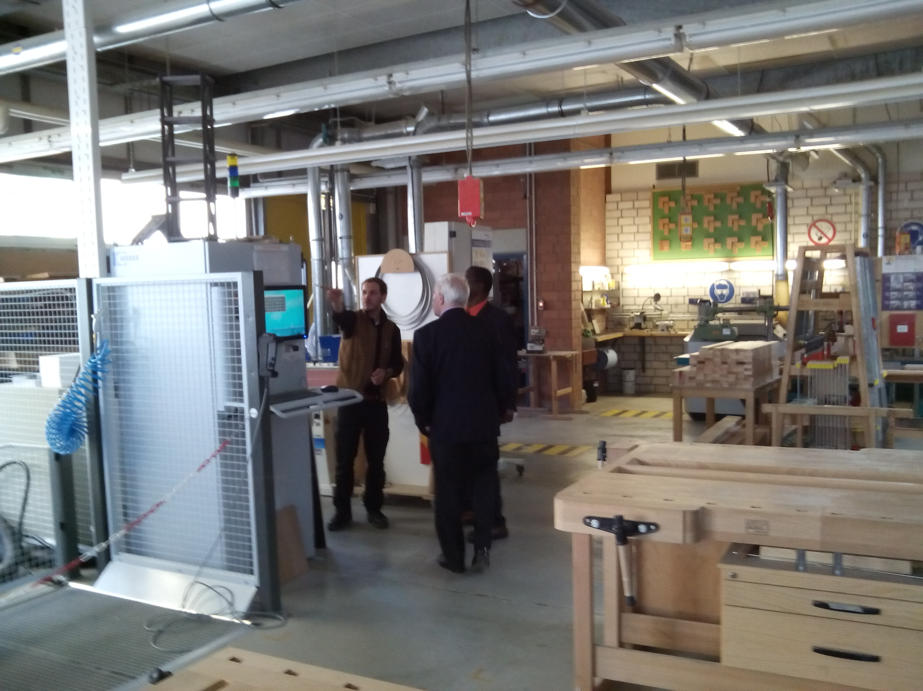
Figure 1: Picture showing joinery teacher explaining machine function
At Cologne Chamber training facility
The unspoken assumption governing these chamber training operations became evident: training environment must mirror closely, if not supersede that which industry provides. Transition from training environment to workplace must create no dissonance in students in terms of tools, equipment and standards of workmanship.
The auto-mechanic workshop was equally impressive with clean, ventilation system and expansive interior resembling large modern vehicle manufacturing plants. Audi, BMW, Mercedes, Renault and Cetreon were all present each with its own modern electrical/electronic training and testing tools, equipment and display boards. Outside
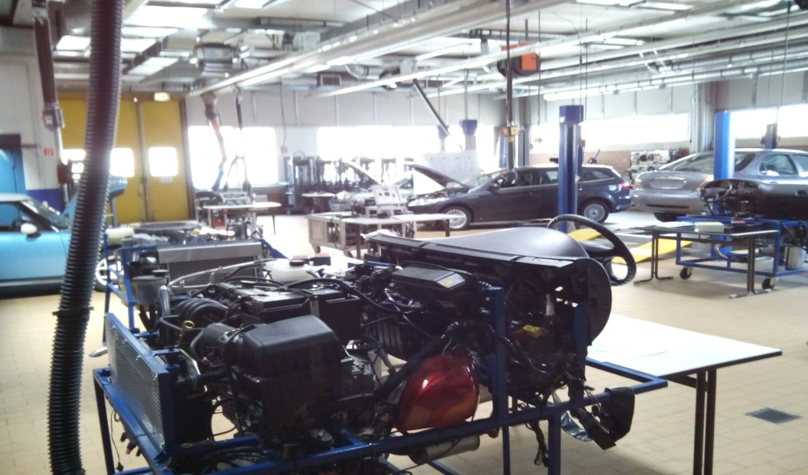
Figure 2: Auto facility at Cologne Chamber training facility

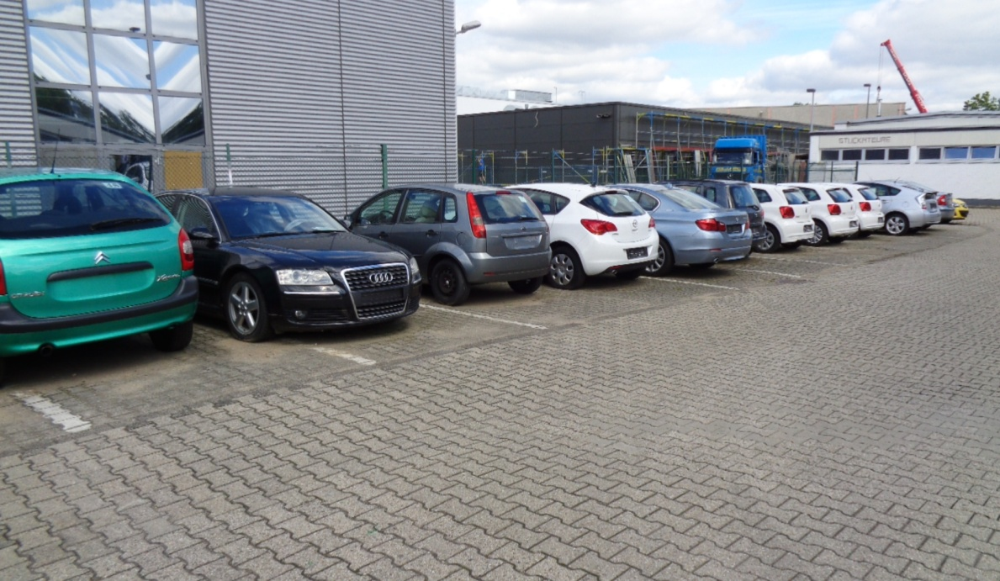
was even more instructive: almost two dozen vehicles in very good working condition of similar manufacturer but too old for the modern training conducted inside.
Figure 3: Vehicle too old for training awaiting removal

Equally impressive was the Chamber of Small Business and Skilled Trades Westfalia in Arnsberg. This Chamber administration and training facilities seem modern represents 11,000 companies, 80,000 employees and 6,000 apprentices. It has a 14 super equipped department including sanitary, heating and air-conditioning, with a more business focussed and boast of clients from other European, pacific and Asian countries. Its strengths seemed to be it motor vehicle and its metal engineering department. Several large vehicle manufacturers not only contribute training material but also conduct specialized training on its compound as was evident with DAF trucks. In addition this Chamber also served as regional training agent for various manufacturers. All technicians working with motor service companies must be certified to work on manufacturers new models and this chamber assumes training function in this respect.
Having to deal with company registration and other things I often wonder what's Chambers' role in training seeing that vocational schools and training guilds also conduct similar program. However, it soon became obvious that schools are limited in terms of space and curriculum contents. Guilds are limited in law and by the fact that they specialized in one occupational area and some of them do no training at all. Skilled Craft Chambers do more varied programs and go deeper into programs in awarding advance qualifications. A major function of Chambers is their ability to link registered companies and training institutions into an interlocking relationship that ensures training content are relevant, meaningful, integrated and above all, authentic.
It was not difficult from these exposures to determine the focus of these training. High quality competence of graduates as well as ensure company based labour market relevance were the more visible evidence. It is evident that a 16-year old immersed in this enrich environment will be attracted to not just the sophisticated equipment themselves but also what these pieces can actually produced thus experiencing a deeper engagement with these artefacts. The spaces were expansive, clean and appeal to something from deep within the person.
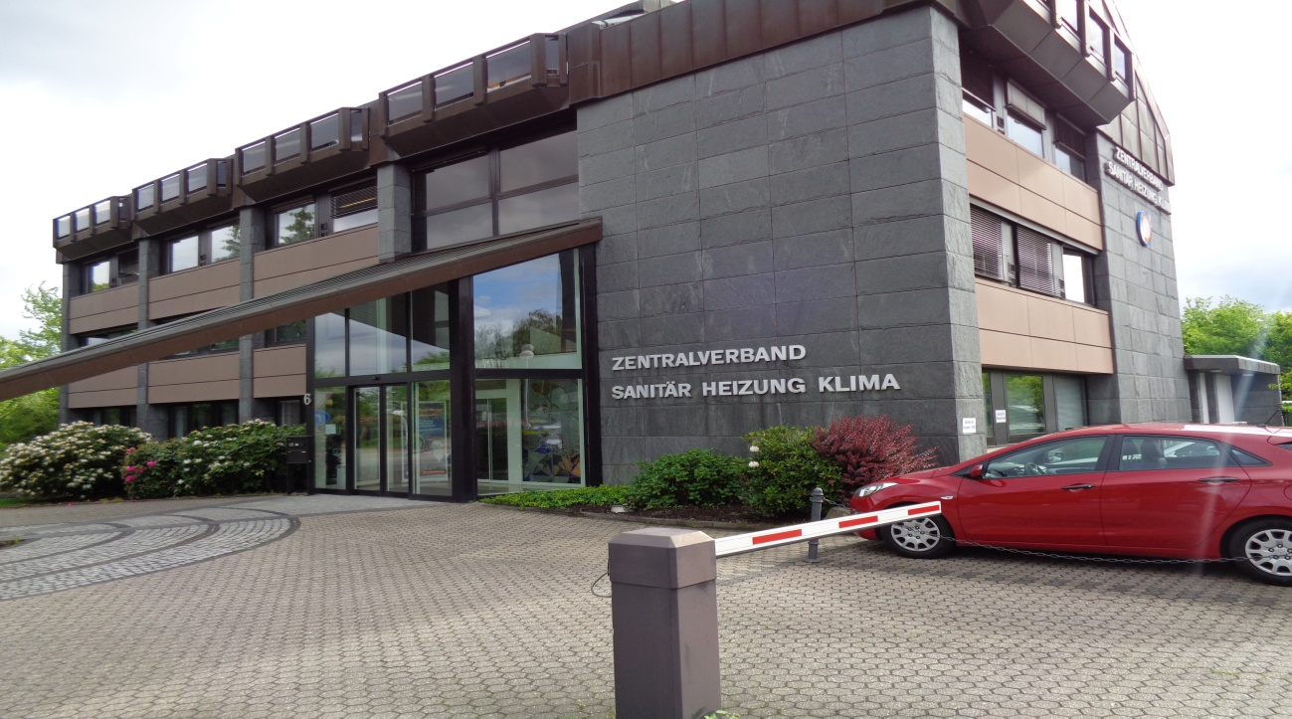
Within ZDK organizational structure is the National Association for plumbing heating and air-conditioning, Zentralverband Sanitar, Heizung Klima (ZHSK). Its business model includes water, heating, air and environment or renewable energies. Figure 4 shows the impressive ZHSK headquarters in St. Augustin, Bonn. ZHSK has regional offices in all Federal States or Landers. It has supervisory responsibility for the activities of the nation's 430 plumbing guilds. It is a national policy that no company operating within the industry can practice without being registered with ZHSK. There
Figure 4 Picture of plumbing, heating and air-conditioning headquarters in
St. Augustin

are more than 30,000 such plumbing, heating and air-conditioning companies existing nationwide with the majority employing between 3-8 workers. Often companies work in one or two fields. There are also approximately 275,000 employees registered with ZHSK and depend on them for direction, consultation and training to enhanced their economic, educational and personal wellbeing. Because of the intimate linkage between education, training and industry nearly 38,000 apprentices are also registered with ZHSK.
Plumbing Guilds are part of the structure and organization of plumbing education and training and operate under the ZHSK umbrella. They represent the historical, cultural and evolutionary aspect of the trade. Their functions were not limited to preserving valuable trade knowledge and skills; they were also seen as a powerful social and political force for regulating the thoughts and behaviour of its members as well as bargaining with the powers that be, for special conditions and benefits for its members. Guild also served as powerful regulatory mechanisms that ensure clients receive the benefits and high standards of performance they are paying for. They achieved this quality through their emphasis on training and their insistence that only competent practitioners be allowed to practice. Complaint of improper workmanship by clients usually results in a range of consequences ranging from simple retraining to, expulsion from the guilds in extreme situations. During the industrial revolution with the needs to mass produce skilled workers for industry their influence diminished somewhat. However, through their lobbying expertise they were able to maintain more than ceremonial functions.
Today plumbing guilds have carved out a niche in society that make their existence a necessary and relevant reality. They have refined the art of lobbying as a political process for the development of members interest. Some guild trained plumbers hold the opinion that guilds have refined the art of teaching their special craft interests in ways that cannot be easily duplicated by other institutions and in some jurisdiction their training methods are compulsory. The fact that school-based vocational training emphasizes more theoretical aspects of the vocation and company training emphasize features common to their specific specialization, Guild training are perceived as more broad based and comprehensive than both. There is also the deep feeling because guilds are managed by trained and experienced plumbers that the spirit of the vocation is preserved within them. From my personal experience this is one myth coming down through the ages that may have a tinge of truth embedded in it.
Apart from these institutions and organizations plumbing education is also regulated by the activities of other entities. The Federal Institute for Vocational Education and Training (BIBB) through its ongoing research and consultation with relevant partners constantly makes modification to training. They determine new training occupation modernized existing one by adding new skill, determine when demand for certain type of skills are declining or the significance of a particular vocational program to national development has declined and that the government should ceased teaching it. When government ceases sponsoring a course, useful skills that are part of that course are built up in another closely related program.
Plumbing is also impacted and regulated by other Acts which provide standards of performance requirement. Some of these include Federal Waste Water Act, Drinking water ordinance, Wastewater charges, Federal Soil Conservation Act. For instance, the Waste Water Act is one of a wide range of laws and regulations that ensure the protection from harmful substances and the conservation of water bodies as habitat. The Building Act and the Energy Efficient Act are other legislations which impact and influence the nature and structure of plumbing education. To these can also be added the wide variety of instructional information from material, tools and equipment manufacturing firms which are not written in curriculum but which must be indirectly consulted during installation and construction activities.

4.3.0 What are the pedagogies at work in Germany's plumbing education?
Even the casual observer can reasonably conclude that not just the plumbing education program but also the German vocational agenda has deeper focus, a more authentic grounding not clearly explainable by normal Anglo/American educational teaching, learning and assessment processes. Chiefly responsible for this peculiar focus is the uniquely German concept of bildung. Bildung is a humanistic idea of education that started during the enlightenment. Bildung recognizes a good education as an inalienable right of each human being; the importance of this education to the total development of the individual, this education must cover the entire life of the individual and span all learning environments.
In its classical essence bildung focuses on three core bit of knowing necessary for the total development of the person. An individual must possess knowledge of himself, and this knowledge evolves around concepts such as the duty, industry, freedom, emancipation, autonomy, individualism, responsibility, reason and knowledge. Secondly, bildung insists there must be a relationship between the individual and everything that is outside him; a deep knowledge about nature and the eternal laws governing nature and the entire universe. The final bit of knowing concerns the relationship between the individual and society and this deals with 'how one behaves to be a responsible citizen and how one communicate with other individuals. Bildung ultimate goal is the inner development of the individual's capabilities, capacities, potentialities and human ideal leading to societal peace and order. The array of artefacts pervading vocational workshops are more than just for acquiring technical skills; they are for engaging, shaping and developing the human potential and capabilities.
Bildung main ideas have produced a related learning and teaching theory common called didactics. In short didactics is a way of thinking and asking questions about teaching and learning and subjects the main elements (the teacher, curriculum, contents, and students) to educational analysis. Hopmann et.al (2000) posit that the subject matter is educative if leads to an experience of value, creates intellectual needs, spiritualizes vital drives, forms attitudes and sparks moral understanding clearly these bildung ideas makes no mistake concerning what the focus of education ought to be for it to be sustainable into the future. It emphasizes the human personal development as the beginning end of education. Without a focus on personal development, which seems to be the thrust of many vocational education systems today, vocational education condescends into skills acquisition at the expense of the training of the deeper human sensibilities. Because many vocational programs do not meet these deep human need conditions that VET can contributes to and hasten students premature exit from training program planned to equip for industrial engagement.

4.4.0 What roles do workplaces play the formation of the plumbing identity and
what legislative agenda governs the relationship with plumbing training in
workplaces?
Four workplaces were visited to provide answers to this question. Two included observation of offices and workshops, two included mobile vans one on the jobsite and the other in the office. Generally workplaces in firms and companies are considered as authentic learning environment. Schools considered, workplaces constitute the most important aspects of the dual system of vocational training. In fact, in some cases in this lovely country workplaces can stand as complete alternatives to the school system. It is within these confine spaces, sometimes shutout from the rest of the world that apprentices engage the vocation as a prefigured cultural entity with its own unique history, personalities, deities, beliefs, values, artefacts, language, symbols, myths, joys, stigma, fears, hurts, emotions, unique methods of being grasped, rewards for both acceptable and objectionable performance, opportunities for advancement, and what they would eventually become in the future. Here is where plumbing students would spend three eventful years of their lives observing, feeling, through drawing, through reflection, through discussion, through listening, participate in its practices and rituals finally to assume a plumbers personality. The workplace is the crucible for socializing new comers into the plumbing culture. Coming through this experience they would never be the same person again. Their world from here on would then be constitutive of pipes, heaters, wrenches, lavatory basins etc. As a former trainee of mine once said, “you and the trade become one.” Some student, recognizing and experiencing this enculturation process have prematurely disengaged.
Many small to medium size firms are involved in training absorbing the majority of apprentices. Often, for many of these firms involvement in training seemed the only way of acquiring additional hands to undertake jobs for which positive commitments have already been made, thus making training a welcoming experience.
Plumbing companies wishing to carry out their training responsibilities are mandated by law (the Vocational training Act 2005) to meet minimum standards. They must assure a certain minimum level of equipment, tools, space, furnishing to conduct training activities. The environment must offer protection to students’ health and emotional wellbeing. Those training companies I visited were really stacked to the fullest with new, old and used plumbing goods making their environments enriched places of discovery learning. According to Jobstarter (2010) trainee should be able to learn in their training companies everything they will need for their future working life. They specified that enough qualified personnel must be present to ensure the success of the training program. Generally, plumbing masters are owners of firms undertaking plumbing training, and as such will have vested interests in the quality of training apprentices receive since they are more than likely to remain with the firm at the completion of their apprenticeship contract.

4.5.0 Is the German plumbing education program identity focus?
Holland, Dagier and Power (1980) provide ideas of what constitute vocational identity. They defined vocational identity as the stable ideas, attitudes, interests, goals and other capacites an individual has for a particular vocation. Furthermore, Etienne Wenger (1998) author of “Community of Practice” provided some guidance on identity formation in answering this question. He suggested three simple conditions that must be present in any consideration of identity formation. These conditions are engagement, imagination and alignment and they are negotiated during the process of concentrated participation with the vocation in the workplaces.
The German plumbing dual education and training program satisfied these conditions to a remarkable degree.
The degree to which these conditions are enabled in training program produces variations to the formation of plumbing identity. On an identity continuum variation occur as diffused, foreclosure, moratorium and achieved with diffusion on the lowest end and achieved identity on the highest. By emphasizing workplace engagement, by providing realistic opportunities for imagination (students seeing themselves in the future as businesspeople, scholars, scientists) German plumbing education program can be considered as highly identity focus. Often when the plumbing identity is sufficiently developed secure commitments towards the vocation developed as well and the individual is ready for the workplace. It is this identification that differentiates a worker from one vocation from that of another.
4.6.0 What incentives attract and sustain plumbing students' interests over the
course of their training?
In the schools, colleges and workplaces I visited where students were present, observations showed numerous features acting singly or in unison with great potential in motivating and sustaining students’ interests for the duration of their training period. The typical German plumbing, heating and air-conditioning apprenticeship program runs for 3 – 3½ years. This is a long time indeed. It is either German plumbing students are intrinsically motivated to endure this period or the plumbing program itself is extremely interesting. I believe both and much more. Other motivating and interest enhancing factors observed are:
- Agency; self chosen field
- the clean, safe socially, emotionally and healthy environment provided for learning
- the deep engaging way the vocation is taught;
- their personal interest;
- the beauty of the course itself;
- the infusion of technology rich tools, equipment, machines and machines embedded in training;
- skilled and knowledgeable masters with higher vocational qualification as instructors;
- availability of an abundance of training material, tools and equipment;
- a visible career path;
- immediate and continuous employment in the trade after training;
- cooperative small group learning promoted;
- classroom more like research centres rather than workshops;
The motivating features of the workplace include
- immersion in the culture rich plumbing world;
- interaction with journeymen and masters;
- perform actual plumbing tasks, using actual tools, equipment and materials;
- contribute to solving technical problems and challenges;
- receiving immediate feedback on performance from fellow employees including masters;
- satisfy customer, employers and colleagues;
- receive remuneration equal to approximately 1/3 that of skilled plumbers; and
- experience the self and identity grow into the vocation and
- visualized future possibilities (as entrepreneur, business person, innovator, skilled practitioner and master).

4.7.0 What personality type is the German plumbing education tending to
produce?
Personality is defined as the characteristic ways in which an individual behaves, thinks and feels (Ormrod & DeVitt, 2004). Holland proposed six personality types that people or groups can fall into (Realistic, Investigative, Artistic, Social, Enterprising and Conventional). He even suggested that these personality types can be used to describe workplaces. A literature search of the US Department of Labour O*Net website suggest, a Realistic, Conventional and Investigative (RIC) personality type as the designated personality type of plumbers with Realistic being the strongest personality type and Conventional being the least strong. Realistic is the capacity for engaging in practical real-world activities. Conventional involves being able to follow set procedures and routine. Investigative means being involve in intensive thinking and using ideas to mentally solve problems. My own candid opinion of the German plumbing education and training program is that it tends towards not just a personality type but also a strong one that is Realistic, Investigative and Social (RIS).

4.8.0 What special orientation process initiates young plumbing aspirants into the community of plumbers?
The transition from secondary schools to vocational school constitutes a major movement for the majority of German school children. Months before leaving secondary school every student is keenly involved in transition activities concerning movement to further academic institutions or signing apprenticeship contracts in one of 340 training occupation. An array of guidance and school counselling resources are available to assist students in their vocational decision making. A plumbing apprentice from Arnsberg said he was assisted in his choice of a vocation by the Employment Agency and this seemed to be popular source of assistance by many apprentices. Vocational guidance advisors from the Germany's Employment Agency and training advisors from competent bodies (chambers) advertised for companies. The CEO of a large plumbing company in Cologne said they visit certain schools and specify the type of student they are interested in and signs him up. No 'out of the ordinary' initial plumbing orientation process was observed or hinted by employers or teachers. In schools we visited new comers to the plumbing vocation are given the normal class welcome tour of plumbing training facilities with accompanying expectation and requirements.
In the workplace things seemed little different. New students would report to the firm's head office shown around the office/workshop facilities, meet staff then finally assigned to plumbing workshop. It is within firms workshop that any peculiar introductory antics are usually demonstrated (a squeeze, a hug) enough to make them feel at home among plumbers and to wet their appetite for the experience that follows over the next three years.
These shops are usually a fascination. The ones I visited overflowed with an array of new, used and damaged plumbing goods to trigger the imagination of newcomers. They were not arranged in the best order and it seems to be the apprentice duty sometime in the future to give some form of order to. One of the more fascinating and attractive device to new learner on the firm side of things is the promise of employment after completing training. Generally their perspective of a perfect plumbing aspirant is one with qualification in maths, physics and chemistry. There never seem to be enough students; there are always more training places than trainees in plumbing to fill them, he concluded. One Bonn construction company frustrated by the inability to find even apprentices source their plumbers from Poland. On an Arnsberg construction plumbers were from Ukraine.
Even students who are not too sure what they want to, or those without appropriate vocational qualification or even those with behaviour problems are not left without opportunity to make the transition into the dual system. In many cases these students are provided with reasonable opportunity to acquire vocational expertise by being sent on prevocational training with companies to assist them in coming to final decision on a choice. The idea is that all school leavers must be occupied. Fortunately in plumbing, heating and air-conditioning there are more training spaces than applicant to fill them.

4.9.0 How does sustainable health and environmental issues integrate into the plumbing studies students receive?
Water, air and soil are necessary for human, animal and plant life. However, these can easily become contaminated and hazardous to health and the environment. If there is a European country that really takes health and environmental protection serious seemed to be Germany; no wonder some of the most beautiful environmental spaces are within its borders. They have some of the most stringent health and environmental laws on the continent. As the picture below shows even trees have rights that must be respect and protected.
Plumbing, heating and air-conditioning are intensive and extensive activities that can easily in the absence of appropriate controls have serious unwanted health and environmental impacts. German plumbing education makes sustainable contribution to health and environment protection in several ways. From a health perspective apart from the other means of ensuring functional integrity of system installation, it stresses the importance of eliminating stagnation conditions in hot and cold water system and backflow conditions in piping conditions. These two conditions if not eliminated encouraged the growth of dangerous micro-organism and the entry of dangerous substances into the drinking water piping system.
Germany also promotes efficiency in resource use. Extracting and process mineral/ore resource anywhere is always associated with some form of environmental stress with emission into the air, soil and water. Reducing resource usage would always have reduced impact upon the environment. The same can also be said of energy. Increase resource use increases energy usage as well. Energy is used in building for heating and cooling, ventilation, lighting and the preparation of hot sanitary water among them and great efforts are now being made to significantly reduced energy consumption. Fossilized forms of energy always increase carbon emission. Thus schools, guilds, and chambers in conducting their plumbing training showed a rich array of alternative renewable energy source equipments in their cooling and heating systems including solar, heat pump, voltaic media etc. Also, visible to observers to these institutions are efforts made to carefully dimensioned, assembled, insulate pipes and ducts and to locate these in an efficient manner to minimize energy loss. These modifications are geared towards reducing fossil fuel consumption and the resulting effect upon the environment.
Also on a reduction mode is water. As was said before energy is required to extract, transport, treat and distribute water to customers. Reducing water-use tantamounts to reducing energy consumption and its concomitant environmental effects. Several water efficient plumbing fixtures are now available to consumers and are present in the training environment. These water efficiency systems have made the country one of the more economical users of water in Europe. Although much was not seen regarding sewage this is a major polluter of waterway and Germany is well served by waste water treatment facilities. There are over 10,000 such facilities across the country. However, Federal Water Act (WHG) stipulates that pollutants contained in drainage water must be reduced in line with available technology.

SECTION 5

Discussion

5.0.0 Introduction

The answers proposed by respondents (teachers, students, apprentices and employers) of the German plumbing education system and the observations made by this observer are briefly discussed in this section. In essence the study/tour looked at the capacity of the German plumbing education system to shape the plumbing identity early in new entrants training. The findings where applicable, would be useful in informing plumbing education thinking and strategies in a local training institution in Trinidad and Tobago where drop-outs from plumbing programs are of major concern and if possible generalized to other local training institutions. The thinking is, if the plumbing identity can be shaped early during training then this could serve as a deterrent to combat high incidents of drop out from plumbing training programs thus militate against the corollary effects drop-out has upon plumbing practice at a time when old plumbers are retiring and fewer newcomers are entering the profession.

5.1.0 Education system and schools
The overall results of the observations suggest a vocational system with excellent structures for the formation of the plumbing identity in young people. The system captures young people at a period in their lives when they are most susceptible to identity shaping. A cursory glance at the German education system suggests an articulated structure commencing from primary education through to university. Primary education prepares students for secondary and secondary schools prepare students for either further academic work of vocational school then into the industry. Several types of secondary schools exist along with professional and other vocational counselling services to clarify students’ abilities, goals, interests, strengths and intentions as early as possible. An even more diverse array of vocational schools including many workplaces is available to enable young people to smoothly make the transition into the world of work. Plumbing students falls within this education structure. Few countries have been successful as Germany in this respect. This system evolved overtime with the historical, cultural social and economic development of the country and thus find easy acceptance with native aspirations.
From the results obtained several important issues arose which deserved further discussion.

5.2.0 Philosophical and historical underpinning
The finding showed that German education system has philosophical underpinning. An educational philosophy is simply a set of enduring beliefs about the purposes and aims and outcomes of education, nature of students, role of teachers, the emphasis of the curriculum, and the social functions of schools that educators used to analyze certain aspects of schools’ operation. These are important tools for guiding educational practice, comparing practices, making modification to practice as well as create new practices. Without such organizing tools education would be difficult to conceptualized and organized in practice and probably be more difficult to generalize effectively to other situations.
The study/tour found that Germany education has strong historical and philosophical roots and even stronger plumbing education traditions which they are not too eager to depart from. This is not strange since they have produced some of the most influential thinkers (Kant, Weber, Froebel) to grace the European continent. They have had long experience with humanistic thinking emanating from their Greco-Roman traditions which came forcefully to the fore during the enlightenment. Because these ideas have served them well in the past explains their reluctance to entirely do away with them. These ways of seeing education, the students, the teacher, subject matter and the curriculum all have strongly influence activities in primary, secondary schools and vocational schools. Even though it was not clearly articulated by some of the plumbing respondents, (this may have resulted from the language communication barrier) to anyone aware of this dimension of education, it’s clearly identifiable through their education system. It is critically important that educational foundation be premised upon reliable and stable foundation rather than upon opportunism, expediency, speculative and whimsical ideas concerning the meaning and purpose of life and education. What is the nature of plumbing reality, the meaning and source of plumbing knowledge and the structure of plumbing values? Depending on how these questions are answered by vocational policy experts would determine the nature of their vocational learning enterprise, the aims of education, the methodology to be used, the outcome expected, how it is evaluated, the degree to which these goals are attainable or whether they are attainable at all. The idealist Germans have not departed much from their tested and tried traditional humanistic position on these ideas and have built their educational empire upon these enduring assumptions. Base on institutions visited they have not spared the cost in constructing the environment necessary for the development of its young people.
Like this great country, Trinidad and Tobago has adopted philosophical positions concerning its educational projects. It has been labeled as man-centered rather than strictly humanistic. But whether we have similar views of the nature of learners, the role of teachers, teaching methodologies, curricular emphasis, the nature of vocational reality, source of knowledge etc, is not difficult to see. Take, for example the nature of vocational reality. Germans view vocational reality or the appropriate environment for constructing the plumbing identity, as happening within workplaces and they ensure that students capture it there, in its sublime essence. Although we are aware that it happens there we continually neglect that reality and settled for something contrived up in classrooms yet we expect comparable results. What follows in my institution is what this study/tour is attempting to address. The example suggests that where differences in vocational outcomes exist, these may be more differences or conflicts between our philosophic educational beliefs and educational practices and thus this may account for the variations in our educational outcomes when compared with the Germans.
With respect to educational theories, the findings suggest that in the plumbing learning environs although socio-cultural factors indexed operation largely on account of its workplace involvement, one can hardly missed the humanistic influence bearing down on plumbing education. The findings indicated that German concept of education differs noticeable from Anglo/American conception of education. German idea of education is understood through the principles of bildung and its derivative, didactics. These ideas ensure that the objects of education remain primarily on the learner. This is the objective of education. Bildung and didactics demand that contents be educative in more than superficial ways. To be educative the objects of education must form attitudes, create intellectual needs, spark moral understanding and elicit a sense of value (Hopmann et.al, 2000). Bildung/didactics requires that teachers model the curriculum or the attitude they wish students to embrace. To do so naturally suggests that the curriculum, rather the vocation must be a part of teachers’ personality suggesting they themselves must have achieved identification with the vocation. Without this personalization of the curriculum and the modeling of it, plumbing teaching becomes an obsession with skills training and a central focus on something else.
In reflecting on the German vocational education and training program of the institutions visited I am amazed at the high degree to which the plumbing education system attempts to operationalize theoretical assumptions within their practice. Whether it’s space allocation per individual, health and safety requirement or consumables for training, they do not budge; they spare no cost. Or the extent to which changes in vocational and indeed plumbing education is influenced by the finding of current research. No wonder they are generally characterized as “Idealist German.” It’s the ideal or nothing else. Thus in the vocational school and workshops the sophisticated tools, equipment, machineries, the compactness of the training program make statement about how learners are perceived, the powers, capabilities and capacities attributed to them (a ideal person) and their scope for development. In a sense these are indications of higher than what holds elsewhere, capabilities accorded young citizens. Hence the functions of these sophisticated tools, equipments, machineries seemed more to construct the type of individuals society requires than tools for preparing them for industry.
The results found teachers as models were a pervasive theme common to all form of schooling. In vocational school, to make it more student-centered, didactics insists that meister must master and first be that which his students must become. To give real effect to curriculum delivery, they insist that teachers must be qualified as masters or a predetermined equivalent minimum level. They are also expected to be in fulltime employment. According to a plumbing teacher at the European college rare are the occasions that one is detract from his essential teaching or modeling role through private practice. And meister’s engagement with students makes a huge difference in the extent to which reasonable identification with the vocation is achieved from training experiences. True to its humanistic tradition bildung/didactics maintains its focus on the individual as the beginning and the end of education.
Further, German plumbing training program is undertaken with two related consideration behind: ‘sense of vocation’ on one hand and ‘what it means to be human person’. From the point of view of the ‘sense of vocation’ the aim is to insure that when individuals come into the vocation they develop lifelong attachment or are socialized to such a degree so as to make lifetime commitment to the vocation. Many opportunities are provided with the necessary protection to enables such possibilities. Post journeyman’s training, other advance training programs and guaranteed employment makes sure the process of vacationing continues throughout their lives. It makes little sense, if any at all, training people in one skilled area only for them to leave after short periods of engagement. Training must also be so related to society such that when an individual is truly inducted into the vocation he is also socialized into society’s norms. The educational pathway is provided to accomplish these objectives. The role of chambers of craft to both accept registration of related companies and overseer training provide protection and comfort for those involved in the trade to develop a sense of vocational purpose and to grow and flourish within it.
In the local context such deep conception about the role of education is relatively unknown among the many plumbing teachers. Many of them teach with only a craft diploma and two years post training industrial experiences sufficient to form only superficial relationship with the vocation but woefully inadequate for plumbing identity purposes. Thus, there is no being a plumber; consequently he cannot teach what he is not. With follows is the tendency to teach a vocation as if the outcome is acquiring knowledge as in teaching mathematics and physic. Socialization, the process craft training requires is unknown and thus ignored while teaching techniques commonly required for teach mathematic and physic predominate to the frustration of newcomers on the periphery of the plumbing community.
The finding also indicated that typical Germany’s journeyman’s plumbing program is integrated with heating and air conditioning. This suggest that plumbing program must be compact with intellectual rigor for without these qualities the program lacks the capacity to excite wonder grow new capabilities, ignite and sustain interest over the course of study. Without compactness the program has to be too thinly stretched and loses meaning in the process. Further, the results indicated that for plumbing education in dual system to be effectively organized and administered it must be overseen by competent bodies. These bodies must have more than just a passing interest in plumbing education. They must have deeper interests in the wider development of the practice itself. Chambers of skilled craft, operating in tandem with ZHSK, and the plumbing guilds are predisposed to fulfill these roles. Through their mandate as register of affiliated businesses they can bring workplaces and schools together in an almost inseparable union to ensure course relevance and smoother transition between workplaces and school-based classrooms.
German plumbing program are three to three and one half years long. This is not an arbitrarily arrived at number. Neither was it determined to allow masters or firms to recover cost expended in apprentice training. It has more to it. It is quite clear that from their long tradition of plumbing apprenticeship training they would have been informed about what is a reasonable period of training necessary to develop the plumbing consciousness, the plumbing attitude or the plumbing identity. Thus three to three and one half years of training is reasonably expected to equipped young individuals with the deep knowledge, skills and attitude for lifelong commitment to the vocation. There is also the addition benefit that socialization into vocation tantamount to socialization into society’s norms because of the vocation’s role as an agent of society.
In the local context without a tradition of training like the Germans, the concept of plumbing as vocation does not arise nor is it discussed; plumbing training is not seen as contributing to social stable society. The institution necessary to bring plumbing teachers or skilled artisans together is totally absent. The focus is a narrow emphasis to acquire skills and knowledge quickly enough to satisfy industry’s needs.
Generally plumbing courses are pitched at level I and few levels II are available. This is because of the recent adoption of competency based training in the Caribbean. Level I can be described as an introductory program which can easily be achieved through normal school-based training and lasting between eight to twenty-four months depending on the type of school. Short eight months plumbing courses litter the local environment. With some programs there is a compulsory “On-The-job” component that last for a month, two months. However these are tailored more towards providing workplace exposure rather than acquiring the unique culture which the vocation proposes. Neither are efforts made to promote a workplace learning culture where qualified masters are available to scaffold newcomers into the vocation; what is available holds. Although these programs are monitored by an agency responsible for training the nature and emphasis of the program renders it incapable of forging deep engagement with trainees. Again these are all evidence of a lack of a philosophical and theoretical foundation guiding plumbing education.

5.3.0 The context of training
It is quite clear that the context of training has also been clearly determined and there must be no deviation from that. Although there are some fulltime school based plumbing program, the general norm is the dual apprenticeship. Three to four days per week students immerse themselves within workplaces to connect the trade for three to three and one-half years of sustain engagement promote the type of socialization necessary to elicit a commitment to the vocation. For the vast majority of realschule, hauptschule and gesameschule students this is a welcome relief from the boredom of a strict academic program which seems to benefit not the majority of students. For many of these adolescence engaging workplace activities satisfy their immediate physiological needs, psychological needs for competence, autonomy and relatedness and with workplace responsibilities can even bring them to adult maturity much earlier.
For many young people participation in workplace activities involving climbing, walking, pulling, lifting, cutting, threading even to sometimes compete with other cohort on the job can satisfy their needs for physiological activity even promote physical growth. Contributing to real physical projects, working competently whether designing and/or assembling heating system and cooling system can expand their emerging sense of plumbing self, and increase their plumbing self-esteem, plumbing self-concept and their plumbing self -efficacy heightening their vocational interest and extending their enjoyment of the beautiful trade.

5.4.0 Identity and personality focus
The findings suggest that many of the conditions necessary for identity formation can be found within the German dual education system. According to the 1999–2003 Fame Report identity formation is a workplace function. German plumbing (dual) education system from the onset, as a priority, socializes newcomers into the vocation by bringing them into direct contact with workplaces, the epicentre of the plumbing culture, and the plumbing world and makes sure they remain in this environment long enough for the plumbing identity to not just take shape but also to stabilize it. This capacity of the German vocational training experience is well supported in the literature (Rauner, 2007; Hassler, 2007) and constitutes a model, the standard by which other systems are compared. Even for the uninitiated such exposure has the potential to create early arousal and sustains interests by bringing students into direct contact with the rich array of plumbing artefacts (beliefs, values, tools, systems, rules, codes and regulations, pain, histories). In the schools, chamber training centres, guilds these rich display of modern plumbing artefacts as teaching tools, add to the powerful impetus toward the plumbing identity formation already taking shape in the workplace.
To the extent that the plumbing program builds identity it also shaped a unique plumbing personality. These two characteristics make plumbers distinct from any other skilled craft personnel imparting unique ways of seeing the world and responding to it. A factor responsible for this is the time newcomers remain engaged with the vocation during training. As mentioned earlier, more than any other country German apprenticeship history has taught them that 3–4 day a week for 3–3½ years of intense and concentrated engagement can be reliably counted upon to shape an equally stable personality. The personality formed is labelled Realistic Investigative and Social (RIS). It is Realistic because it accentuates workplace practice; it is Investigative because of the nature of the school part of the dual system which suggests an emphasis on analysis and investigation of plumbing phenomena. Then there is a toss-up between Conventional and Social. However I selected Social. Social because of the wider political culture of the nation, the cooperative nature of classroom teaching and the special focus on customer satisfaction. More than that, the trade itself emerged from a historical, cultural and social origin that calls for a similar approach towards it effective transmission. To attempts to alter transmission process alters not only plumbing itself but also the personality formed as well. For, to the degree that learning a trade moves away from authentic sites, the method of transmission changes, skills are separated from the practice of that trade and the personality changes also.
This (RIS) closely matches the Realistic Investigative Conventional (RIC) type suggested by the American Department of Labor O*Net data base. This is the authentic personality formed in authentic setting. Few other plumbing training programs have such potential for identity and personality formation. In sampling the personality of students in my last class (2012-2013) it was found that the dominant plumbing personality for most of the respondents was Social on the Holland Personality Inventory. When a sample of the entire institution was likewise tested it was found to be more Social than the plumbing class. What this suggested was that if the plumbing program is not compact and realistic enough students can assume a personality resembling the type proffered by the school rather than the personality the vocation offers. Expressed another way, if plumbing is learnt in less than authentic environments there is a movement away from the authentic personality which would be formed and something else is formed ( a less than authentic personality would be formed). On the Holland personality chart Social personality type is opposite to Realistic type suggesting a movement in the opposite direction. Thus, in our case it was the opposite personality type that grew in significance.
Ironically, the personality connection with vocational education is nothing new. It was Cedefop (2009) which suggested that ‘career guidance should not be solely concern with students’ future profession but also with complex questions about their identities and personnel orientation with regard to the future, with an urgency to integrate personality and vocation.’ Other programs without such intense workplace engagement as the German’s, must await graduates entry into the workplace for their identity and personality to develop over the course of their employment. In some cases they never develop.
With the plumbing attitude gradually becoming a part of learners’ personality the chances are greater that many more would remain and complete their training and remain with the vocation long after graduation. This seemed a natural and unspoken feature of the German plumbing training program and to a great degree accounted for low levels of attrition. In fact, by the time they graduate from their apprenticeship the identity would have taken shaped even stabilized pointing in a direction towards enhanced commitment.
In this regard unemployment can becomes a real menace to the emerging plumbing identity and personality. The longer plumbing graduates remains unemployed or outside workplaces of their training, the greater the erosion of their goals, interests, attitudes and personality. The more likely graduates are to finding employment in areas inconsistent with their just concluded training. Fortunately, this has not been a German problem; like training places, there are more plumbing jobs than graduates to fill them and plumbing graduates are reasonably well paid as well as seeing a clear path for further career enhancement through their higher level plumbing education system.
Locally, plumbing graduates are not that fortunate. Often, low level I school based graduates lack the experience and confidence to seamlessly fit into complex workplaces from school, for there is no organize seamless transition tradition locally. Although some find job, many, armed with their introductory skills they must individually engage the workplace which by then they are virtual stranger and if successful, they thus must make hard and manful efforts at adjusting.
5.5. Plumbing masters
The master becomes the point at which newcomers make contact with the vocation and it’s his relationship with those artifacts that the apprentice comes to develop values about. A relationship with the master is a relationship with the vocation. He models the vocation. Observing the sites visited showed apprentices in close contact with the master demonstrating high on-task attention and persistence. Picture 1 depicts apprentice engagement with his master. It is the deepening of this relationship that attitudes are transferred and the plumbing identity begins to form and strengthen throughout the duration of the apprenticeship.
Yes, masters they are really something else depending on where you find them. Those in school looked calm and free. On the job they appear engaged and burdened with care. In the guilds they express a calm authority, exude a dignified power, an aura that makes you feel you are part of something sacred. They command a presence, and expressed fatherly care in their charges. I will never forget the one I met up at schwienfurt guild. I have been a plumber for the past forty years, trained under two very good ones, worked with some special one, but never have I felt the way I did as up at schwienfurt.
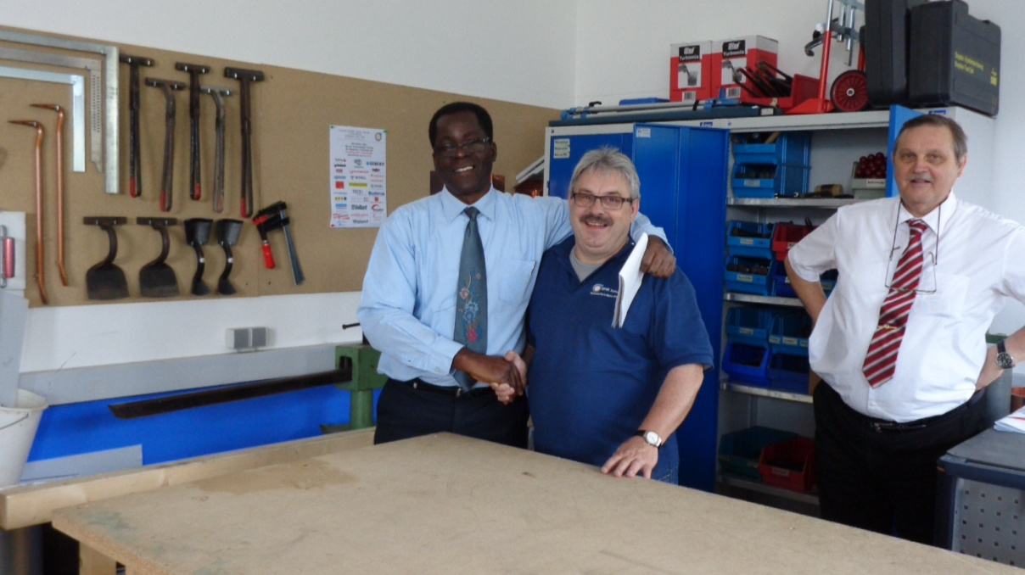
Figure 5 Picture of WPC 2013 scholar Lennox shade, Schweinfurt master and
Mr. Goebel of ZVSHK
In this master presence I felt like I was in school again. He was speaking German but I was feeling every word, yes feeling every word. It was as if kindred spirits gently collided, two people with common interests, goals, ambitions with noteworthy accomplishments came together and in that meeting of body mind and spirit something sparked, a joy, an estatic feeling. I have travelled almost 8000 Kilometres to this small Barvarian town for this occasion to feel the plumbing spirit. It’s something you know exist but cannot say what it is. You are working and experiencing flow; something is building up within you but because you don’t know anything about it and you allow the feeling to recede. They say the spirits live in the guilds. It seemed embodied by these masters. Young men engaging these master teachers soon imbibe the essence of the vocation and feel the spirit. Few other strategies can hasten identity development as engagement of the trade through an emotional bonding with such masters.

5.6.0 Motivation
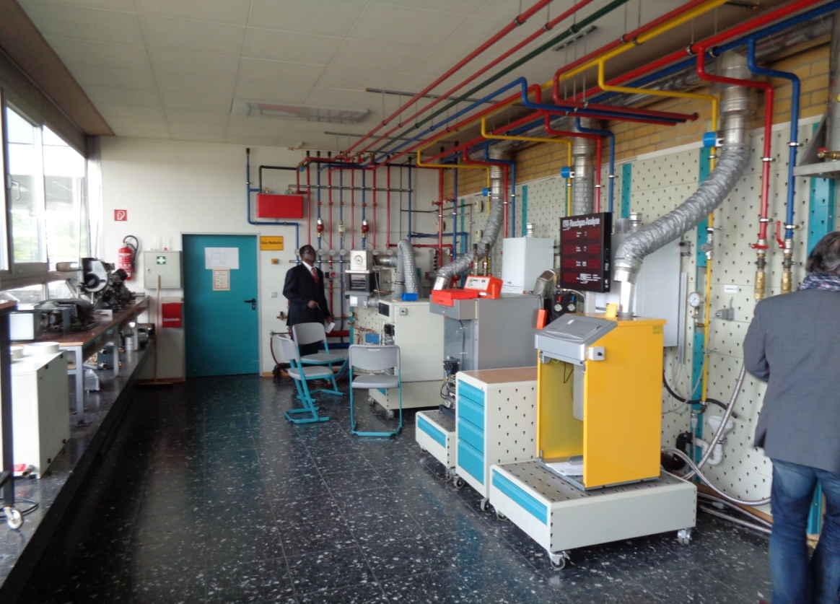
The question of what motivates and sustains interests of German students over the course of their rather long training period is probably the most important issue confronting plumbing educators everywhere. Unlike many other skilled craft area plumbing has a natural inescapable stigma – the scent - which is a bugbear in sustaining
Figure 6: Picturesque plumbing classroom at the European school

students’ interests particularly if this phenomena is experienced early during training. Despite efforts to delay the onset of students engaging this reality during training sometimes it impossible to do so and thus must be confronted and professionally dealt with it.
A very important fact noted among the sample of German plumbing students was personal choice in determining selection of plumbing and this manifested in their general appearance and demeanour. Agency is very important in vocational decision making. It may by the most important one in plumbing. When agency is expressed students are more likely to seek challenge, persist in the face of adversity, perform up to his ability level on a reasonably consistent basis and remain with the vocation.
However, while identity formation to a large extent depends on students’ agency and interests, this is not left solely to them to form and hold intrinsically. A mighty whole lot is done extrinsically. Having visited several chambers, guilds, vocational schools, technical universities and workplaces one pervasive theme was observed: enrich the physical school environment in which plumbing training is conducted. This has been a key strategy in, sometimes, initiating and sustaining student’s interest in the plumbing trade. Industry has its own peculiar way of achieving this. Such approaches represent important socio-cultural ideas that internal though structures and patterns arose first from external social interactions. In other words the activities, the mental processes learners are interested or engaged with now were first posed to them extrinsically and through internalization made of their internal system. Even students without initial exposure would be attracted by the aesthetic appeal of these environments
The first striking contributing factor sustaining plumbing students’ interests seemed to be the school environments. Classrooms and workshops were purposefully designed built and divided separately for plumbing, heating and air-condition. They are usually large spaced out, well ventilated and air-conditioned conveying an immediate feeling of safety and comfort.
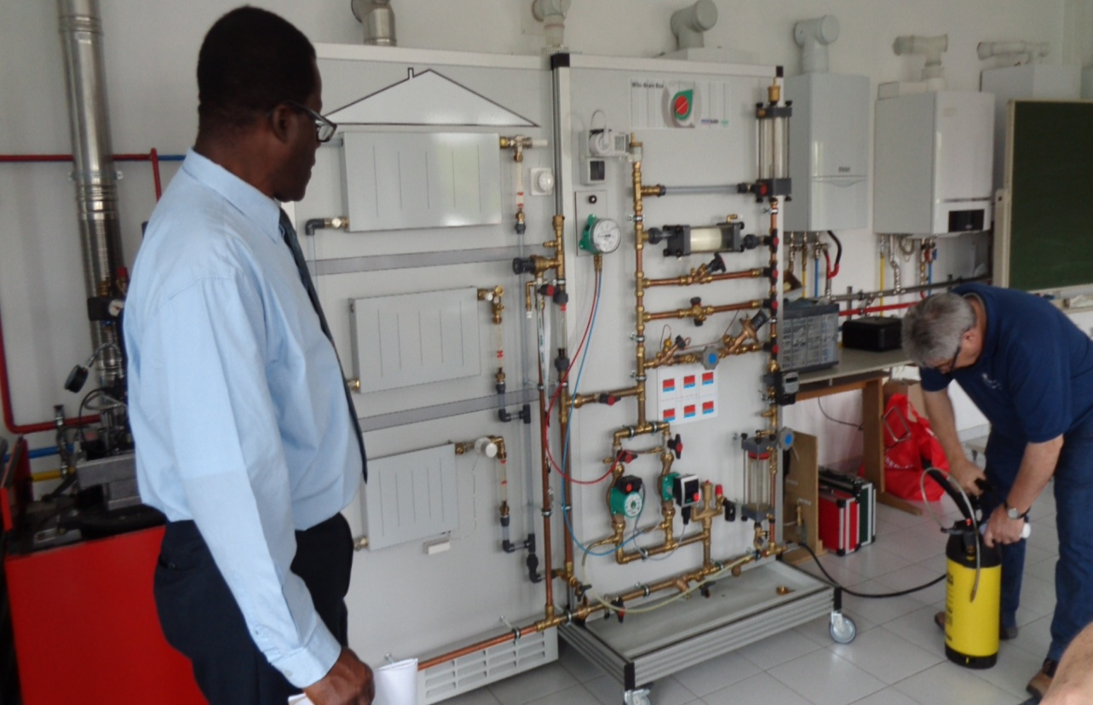
Picture 4: Master at Schienfurt Guild of plumbing charging up heating simulator to measure pressure drop through piping components

One is likely to think that little or no practice is done in dual system schools because of the workplace involvement in the practical aspects of training. This is an erroneous
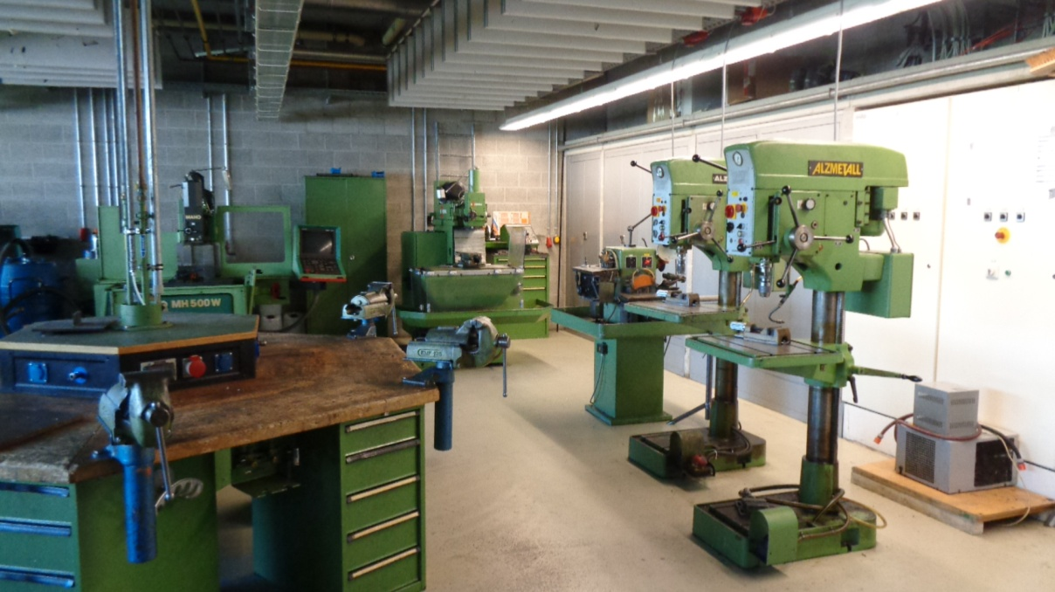
Figure 7: Well equipped school workshops were the order of the day

belief. German school workshops are outfitted with some of the most modern and sophisticated tools and equipment all designed to appeal to students’ curiosity and arouse exploratory potential in those students delaying making up their mind.

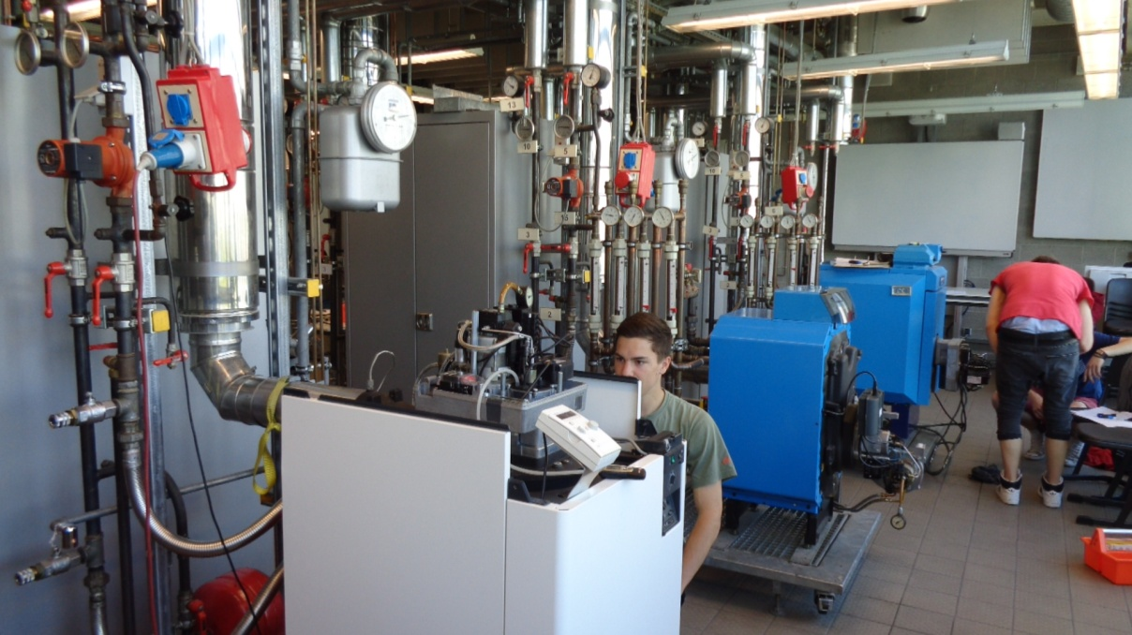
Figure 8: Workshops resembling research lab

Additionally, much classroom and workshop activities often seemed exercises in exploring and investigating common workplaces problems, challenges and phenomena, not duplications of such. This approach seemed a pervasive theme throughout the school
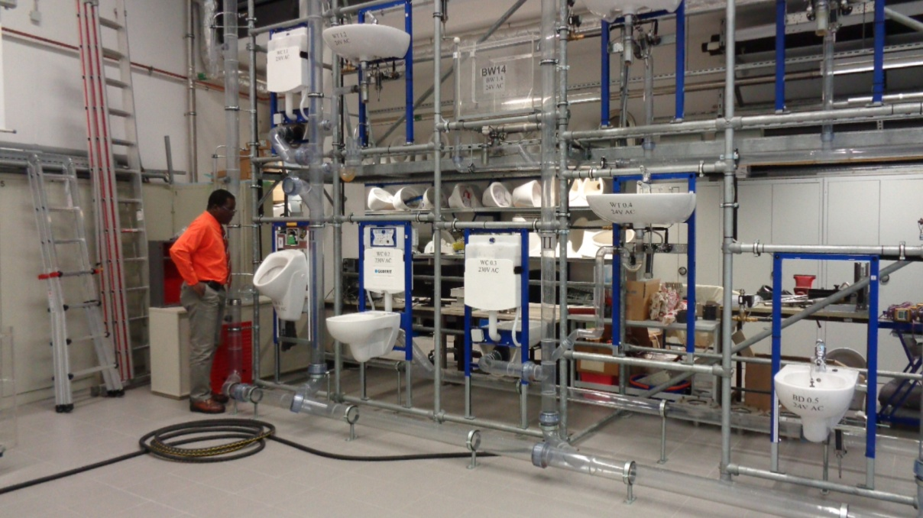
environment whether in plumbing, woodworking or auto-mechanic learning. The guild at schienfurt was an outrageous representation of this. For some students without initial exposure to plumbing enrich environment is a very powerful initial source of motivation.
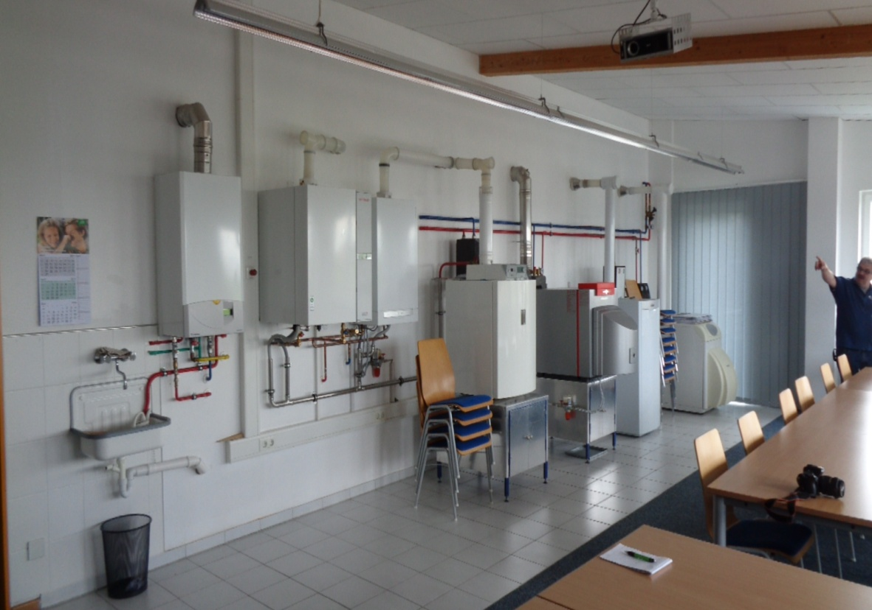

Picture 5: showing various heating units simulating problem situations
apprentices must solve in the classroom
From observing the master at Schienfurt Plumbing Guild in Bavaria and others I concluded that well qualified and experienced masters who love the vocation and students can captivate and hold students interests leading them to commit to the trade. They seemed to have no other interest and are dedicated to teaching and the vocation. These masters recognized one important fact: that as important as vocational skills are their ultimate purpose is to build people. Perhaps consistent with the German social ethos, they appear to humanize the environment by creating warm, social and cooperative atmospheres then through modelling and imitation, articulating and subtle conditioning draw students to themselves and ultimately to the vocation. Interest and excitement becomes visible; they show up on students' faces. Masters thus display
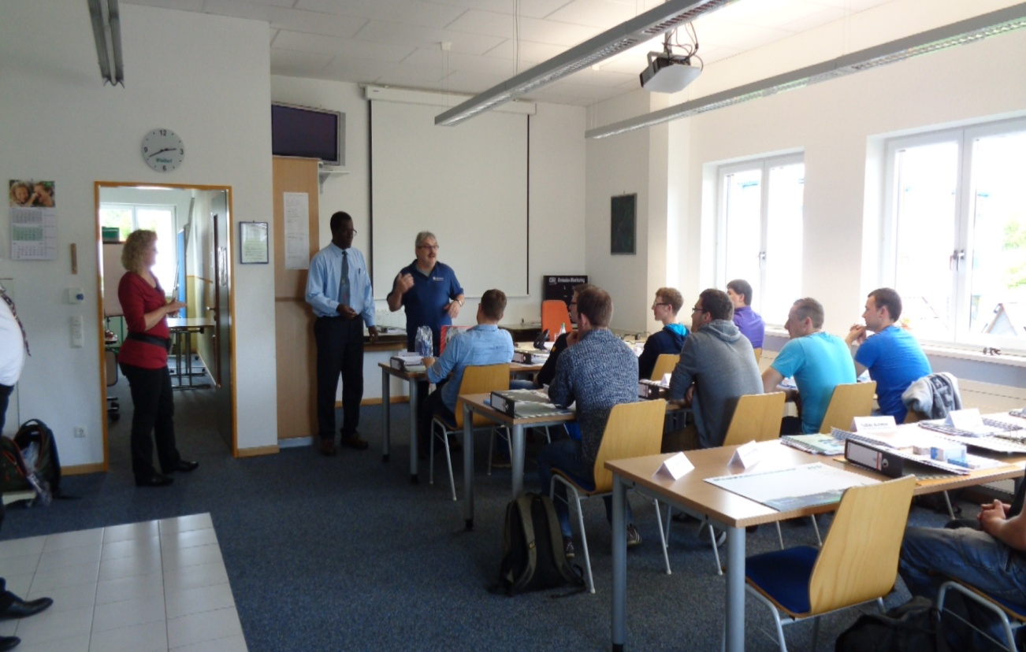

personal interests in students' strengths, weakness, goals and ambitions, their background family experiences, fears and phobia. They open up themselves to scrutiny
and inspection by students. Classroom activities thus become a social affair. Learning is a shared experience in conjunction with interested others. In these environments students feel empowered; they feel they can learn, they can grow, they can achieve and become the next generation of plumbers, masters and entrepreneurs. Even students without initial interest in the vocation will be attracted to this socially warm learning environment and develop affinities with the vocation. Only a master who himself has identified with the vocation can instruct to this level of being.
Thirdly, the plumbing program or the plumbing culture possesses some inherently interesting qualities. There is a sweetness about the plumbing curriculum in term of how it whets your intellectual appetite. Of course this would have significance for some students. Probably it elicits interests in how it bringing diverse students with unique skills together in cooperative endeavours. Probably it’s the practical way in which it demonstrates or explains scientific facts not clearly understood in secondary school settings.
Further, students come to educational environments with numerous psychological needs (competence relatedness and autonomy). A matter of fact vocations can be considered as psychological domains in which students wish to invest themselves. Watching how the self grows in the vocation is stimulating indeed. Or, their persistent with the program suggest, among other things, that the program were satisfying these needs.
The part of the training program more likely to enhance students’ interest is the workplace aspect. All the apprentices interviewed spoke not only of how interesting being on the job is, it was manifested in their general mannerism; they seem free and enjoying it. Watching expert plumbers operate within the myriad of job situations is a gripping situation for newcomers. There is nothing as electrifying as awaiting your turn as an apprentice to complete an important task; it can be not just motivating but exciting. This is where the plumbing practice unfurls. Performing real tasks that would endure for the life of the building in real time, in real space, with real tools test student’s powers and capabilities to the limit and satisfy psychological needs for competence. Working with real plumbers for real customers gaining their approval their acceptance and becoming one of the boys satisfy apprentices’ needs for relatedness in a way that nothing else can. Given opportunities for creativity to see themselves grows promotes individual autonomy. Learning in these authentic setting with experience individuals and the many artefacts available provide access to deep trade knowledge. Here is where interested students being engrossed wish night never comes sometimes. In a country with more plumbing work than plumbers to perform them and knowing that lifelong employment is practically guaranteed exerts a motivating influence upon young plumbing apprentices.
Technology permeates German plumbing industry at all levels of the education and work environment. Schwienfurte Plumbing Guild experiences were the most instructive in terms of the technology infusion into plumbing journeyman and master education programs. The range of heating, cooling, air conditioning equipped with energy efficient systems with integration, purification systems, touchless and waterless systems are making plumbing resemble more an electrical/electronic classroom with emphasis on understanding, installing and maintaining these devices. We have not even listed the new type of pipes and fittings tools and equipments. Such is the impact of these devices that modification to the plumbing curriculum has seen the inclusion of electrical/electronic module added to the plumbing, heating and air-condition curriculum. It boggles the mind what the beautiful trade is evolving into. Hephaestus and Vulcan the Greek and Roman deities assign craft persons are probably full pledge plumbers now.
This has led to modification of the plumbing program.
The computer has become an integral part of the plumbing class akin to a new type of wrench to source, manipulate, analyze, integrate, display, communicate and store plumbing information from a wide variety of sources. In addition, there have been a number of electronic display board multimedia and information technology inputs into traditional delivery and assessment systems. In classroom/workshops electronic simulators boards with rapid coupling fitments simulate any condition within water, stagnation, circulation, drainage piping, venting heating and air-conditioning system across different fitting and fitment. Many of these applicable only in classroom teaching and learning situations, making every point in a piping system open to analysis, testing and evaluation. This situation tells of the close arrangement existing between industry and training
These are just some of the enriched external features of the German plumbing learning environment that students interface with and these are what they internalize. It is these enriched learning environments that the Germany plumbing training distinguishes and distances itself from local arrangements.
Further, knowing that plumbing education and industry practices are protected by powerful organization such as the Chamber of ZDH, ZKSH, unions and guilds are stimulating for students with entrepreneurial ambitions. Making a lifelong commitment to the vocation depends on newcomers being able to vision themselves in the future in several trade related roles. By their registration of firms’ functions these large organizations debar individuals and other organization without appropriate qualification (including masters) but with just a pecuniary interest from getting involve in the business of the vocation. This opens opportunities for duly trained and experiences plumbers getting involve in promoting and refining the trade through the innovations they are likely to bring to their businesses. This reality can be very motivating to young craft aspirants indeed.
Such deeply connected registry and regulatory mechanisms and organizations are absent in our context. What exists locally is that, there is a statutory company regulating water operation and licensed plumbers to perform plumbing related functions. They have no control over the registration of plumbing companies nor are they involve in plumbing craft training beyond that needed to licence plumbers. Training regulations falls under another statutory company, the National Training Agency. There is a National Plumbing Association which unofficially seeks the interests of licences plumbers but does not have a legal relationship with either the water company nor the Agency responsible for training. In this environment many companies performing plumbing functions do not have owners with plumbing training or a license in plumbing, while 99% of plumbing goods sales companies are not owned by licensed, trained and experienced plumbers. This scenario can have a profoundly de-motivating influence upon students’ future goals and ambitions. If students cannot perceive that their current participation in the trade can lead to ownership of aspects of the vocation there is little to elicit a future commitment to the plumbing trade. As a result of this and other related factors the majority of students in many plumbing classes envisage a military future rather than one in the beautiful trade.

SECTION 6

Conclusion, implication and recommendation

6.1.0 Introduction
This study tour entailed a search for answers in a developed country known for its industrial and vocational prowess to address vocational shortcoming in another developing country. As the need for highly trained skilled individuals is growing internationally Germany has positioned itself as an exporter of vocational education and training and countries like India, China, Russia, Turkey and Trinidad and Tobago have already benefitted. For one thing this reality and the findings of this study/tour has confirmed the decision to selecting Germany as a site for observing plumbing education and training impact upon plumbing apprentices interests, goals and attitudes toward the ‘beautiful trade’.
For five jam-pack weeks in April and June 2014 I traversed this lovely country visiting their technical schools, plumbing guilds, chambers of craft training facilities, technical colleges, technical universities and research institution identify factors likely to contribute to low drop rates among plumbing students. What has been identified within training institutions has been nothing less than astounding and this scenario is not by any means limited to plumbing, heating and air-conditioning. Super equipped training and learning facilities went across all the skilled craft areas to awaken and inspire the most vocationally disenchanted. That Germany has one of the lowest youth unemployment rate in Europe is traceable in part to these facilities and their ability to hold students throughout their apprenticeship.
These enviable accomplishments is premised, to a large degree upon German long plumbing education history predating medieval beginning that has been, preserved, and refined with the evolution of the guilds. Closely intertwined with this evolution is its enduring humanistic philosophical underpinning which supported, gave meaning and value not only to education but also to people and the type of environment needed for their development. These enduring values and beliefs were the bedrock that provided stability and coherence to guilds and society especially in times of political uncertainty. Today plumbing is combined with central heating and air-conditioning and taught as a three-in-one program within the dual education system and is the pillar upon which national wellbeing rests.

6.2.0 Broad conclusions
Several broad conclusions can be drawn from the finding of the observations. These are:
- In short, Germany’s pragmatic education system constitutes a well articulated system from primary to university education with the expressed goal of initially getting young people into workplaces as quickly as possible and to continue learning for the rest of their lives. Secondary education chief goal is to determine young people’s abilities, interests, goals and intentions and capacity for either for further academic education or into a plethora of vocational school in preparation for the world of work.
- Its vocational education and training system inclusive of its plumbing training system are founded on the basis of strong humanist/socio-cultural philosophy and historical principles which spell out what the nature of reality, sources of vocational knowledge, nature of apprentices, the role of meisters, teaching methodology, the emphasis of the curriculum and social functions of the school are emphasized
- Bildung and didactics principles also influence curriculum delivery ensuring that training remains students focus by being able to form attitudes, create intellectual needs, spark moral understanding and elicits a value orientation
- Powerful organizations such as chambers of skilled craft, ZKSH, Guilds and research institution (BIBB) with vested and historical interests in the vocation control plumbing at the industry and education level. On the one hand they keep a register of plumbing heating and air conditioning firms in the skilled craft sector. On the other, they administer and certify at the apprentice, journeyman and master’s levels;
- The typical plumbing training program reflects an integration of plumbing, heating and air-conditioning aspects. In a certain sense this integration ensures compactness, intellectual rigor and of 3 – 3½ years duration to make sure that the plumbing attitude is shaped. The program is structured along a path that leads from apprentice, journeyman then through to the masters level;
- As far as possible the theoretical part of the program is done in schools, while the practical part is done in workplaces. Approximately four-fifth of the program duration is spent engaging the vocation in workplaces while the remainder is spent within the school system engaging those theoretical subjects;
- The program is designed and structured to promote maximum engagement and to fire new comers’ imagination with the plumbing culture resulting in a predictable formation of the plumbing identity and personality at the completion of training program.
- There is also seamless transition into the workplace so as not to cause disruption to the plumbing identity being shaped or the personality being formed;
- The personality the plumbing training program is tending to produce based on its structure and operation is classified as Realistic, Investigative and Social (Holland typology). The ideal is Realistic Investigative and Conventional
- Although no specific orientation program for initially socializing young people into plumbing was observed, a number of vocational counselling agencies including plumbing firms visit schools to provide assistance to students in this most important decision making process. This guidance process seemed available throughout the duration of their training to make sure maximum benefits are derived from training to affect not only vocational development but also their holistic development;
- To motivate and hold students’ interests for the duration of the training program institutions rely on outfitting their facilities with some of the most sophisticated tools, equipment, machineries in some of the safest, cleanest and technology enrich learning environment possible. Coupled with qualified and experienced masters fewer students drop-out; thus more acquire plumbing trade qualification;
- To keep these apprentices focus on the learning enterprise they are paid a starting stipend equal to one/third the salary of a journeyman plumber. This is increase yearly as his competence increases over the later part of the training program. At the completion of the apprenticeship employment is almost guarantee thus making the transition into the workplace an almost seamless one
- Health and environmental sustainability is built into the fabric of the vocational training program in several ways including installation elimination of potential backflow contamination conditions, elimination of stagnation conditions, a host of water-use minimization strategies as well as conversion to more energy efficient and alternative sources of energy products.

German dual programs are legendry in its ability to form identity (Rauner, 2007; Haasler, 2007). Compared with the local context gaps exist in the history and evolution of their respective education and training practices. There are gaps in how the plumbing education is conceived, planned and organized, structure and contents of program, operationalized, assessed and evaluated. Even though the programs are conceptually different yet it is their identity forming capacity that is the issue in question. Therefore, the extent to which there is deviation from certain ideal situations, whether conceptually or in operation, plumbing education and training becomes less authentic and frustrates the early emergence of the plumbing identity.
Whilst not all the critical areas can be reasonably implemented in the local context a lot can. Let us be real: Germany is Germany. Key areas of concern including teachers and their roles, the workplaces as authentic sites of learning, and enrich learning environment in schools. Observation confirmed the usefulness of appropriate theories to frame education and practices both in schools and workplaces. Buldung and didactics are the German approaches. These ideas of training centered around what it means to be a human being that the education system in German aims to realized. It is this human focused consideration of their vocational system which separates the German vocation system from many and that which makes it the preferred system by many countries. As such, teacher approach to pedagogy, students’ expectation of the curriculum and the duration of training programs are all influenced by this deeper humanistic understanding of educational thoughts that influences their education system.

6.3.0 Implications
Several implications flow from the conclusion drawn from the finding of this study tour. These are discussed below
- Premised vocational plumbing education and training upon sound, tested, tried and enduring idea and beliefs. These underpinning do not have to be traditional underpinning neither do they have to be identical to the German’s. It could be enduring and common ways that a peculiar society views things like a human, the nature of students the role of teachers, knowledge, what should the curriculum emphasizes, what learning environment best suits what we’ve got, teaching methods and the social functions of not just the school but the social function of the vocation as well. These tasks must of necessity be undertaken by vocational experts: may I say vocational people. Called in the critical stakeholders in vocational (plumbing) education, parents, students, teachers, instructors, educators, psychologist, tradespersons, females, business people, the disabled, the gifted and decide on what it means to be a human being and what is the best environment to produce this individual. For unless we know what a human being is, we won’t know how to develop him. We have to construct notions of this. Involved people. These things (trades) evolved from social historical context. They are about people. They are people. Let them stay with people. Let the ideas be ideas they all have agreement on. They would support it if they are part of the decision making process
- To be consistent with prevailing views plumbing educators urgently need to derived some educational guiding points stating what education should do with and for learners and allow these guiding points to become the operational lens through which you administer and the interpretative lens through which plumbing educational endeavors are evaluated.
- Plumbing needs a strong and independent voice to protect and articulate its interests for its own sake outside of wider educational and labor setting. Efforts must be made to form strong plumbing associations to articulate the views of plumbing and plumbers and other areas of critical interest to the vocation. Once formed a plumbing association must offer a protective arm to both newcomers and those completing their tour of duty. It must overseer plumbing education curriculum and even assumes supervisory functions as it relates to examination and certification. Not to be excluded from this grouping are the regulations of industry practices, registry of plumbing companies and their integration with education to promote greater collaboration, knowledge transfer and seamless transfer into the world of work for young people.
- Plumbing institutions, educators and curriculum specialists need to assess the viability of an identity approach as an alternative to the traditional method of vocational education. This focus carries the potential of directing training deep into the personality of newcomers.
- .There is the needs for lengthening the duration of plumbing training programs to ensure not just identity formation but also identity stabilizing.
- The rigor of the traditional plumbing program needs to increase. This would make it more intellectually demanding. In the absence of heating and air-conditioning, topics like pipe fabrication and pipe fitting can become important substitutes.
- Plumbing classroom needs to be enriched so as to achieve and maintain maximum arousal.
- Plumbing curriculum education specialist need to seriously consider the enormous benefits that workplaces offer and to explore its potential for training in order to maximize students’ engagement, the formation of their plumbing identities and shaping of their personalities. .
- Policy makers must develop strategies that would modify existing workplace entry age requirement to provide opportunities for early and middle adolescent students to access the workplace or other appropriate strategies devised to accommodate them.
- Real opportunities for lifelong education need be provided within the vocation which enables students to see themselves not growing in the trade but taking ownership of its as well. A dead end must not be created at levels as low as level I. to blunt students aspirations for intellectual growth and upward mobility within the vocation.
- Opportunities must be provided for newcomers to the vocation to see themselves as controlling the commanding height of the trade – manufacturing, sales, advertising etc.
- Qualified and experienced plumbing teachers needs to be acquired to engaged newcomers to transmit the plumbing ethos and what it means to be a human being as well as the wider responsibility of commitment to the beliefs and values of the vocation. This goes beyond a mere teaching of skills and knowledge. Only those who were themselves touched by these deeper dimensions should be allowed to engaged newcomers.
- Plumbing teachers needs to provide trade specific guidance and counseling. This has importance for intra-vocation guidance. During the course of study critical stages of the training program are reached and only skilled and trained teachers can navigate students through this program.
- With plumbing more and more becoming tied with protecting the environment, health and environmental sustainability features needs to be an integral feature of the training curriculum.

6.4.0 Recommendation
Several recommendations flowed from the main findings, the conclusion and implications of this study and they are as follows:
- Plumbing education and training needs to be underpinned by tried, tested and enduring philosophical principles.
- Anchor plumbing education and training into a wider plumbing association that seeks the interest of plumbing for its own sake.
- An identity approach to plumbing education and training be adopted.
- Increase the duration of plumbing training program from traditional eight months to two years and over.
- Increase intellectual rigorous and compact of plumbing education and training program by integrating with other pipe trades like pipefitting and pipe fabrication.
- Provide Enrich learning environment that are intellectually and visually pleasing so as to achieve and maintain appropriate levels of arousal.

- Reinstate the workplaces as the only authentic site of learning and identity formation.
- Policy planners must make arrangement for the lowering of the minimum age at which middle adolescent can access workplaces
- Create pathways for upward mobility and lifelong learning within the plumbing vocation by opening up more advance level training.
- Staff plumbing classes with well qualified and experiences individuals who have themselves established identification with the vocation.
- Guidance and counseling must become compulsory requirement for teaching plumbing vocation.
- Make environmental sustainability an integral feature of the plumbing training at all levels.

6.5.0 Final summary
The main objective of this study/tour was to acquire a deeper understanding of the German plumbing education system as it relates to plumbing students identity formation so as to informed training at the National Apprenticeship Centre. The purpose was to acquire information on identity formation and the commitment it engenders to assist in significantly reducing the central problem of attrition at the local institution. Thus based on findings in chapter 4, the conclusions, implications and recommendations discussed in chapter 6 it can be accepted that the study/tour questions were adequately answered and main objective of the study tour was achieved.
Therefore it can be safely concluded that the results of this study has contributed in some ways to the body of knowledge in plumbing education and identity formation.

Bibliography

Bretherton, T. (2011). The role of vocational education and training in workforce
development: a story of conflicting expectations on how Vocational Education
and Training (VET) can contribute to enhancing productivity and increase
workforce participation. NCVER, Adelaide
Cedefop. (2011). Germany. VET in Europe – Country Report
Federal Ministry of Education and Research (2009). Glossary of Vocational Trainng Terms.
Federal Ministry of Education and Research (2013). Report of Vocational Education and Training 2013.
Haasler, B. (2007). Apprentices experiences of occupational and organizational commitment: An empirical investigation in a german automobile company. In: Brown A, Kirpal S, Raunner F. (eds) Identities at work. Springer. Dordrecht. pp. 261-284
Hopmann, K., Westbury, I., Riquarts, S. (2000). Teaching as a reflective practice: the didactic tradition. Lawrence Erlbaum Associates. NJ.
International Renewable Energy Agency (2012). Renewable energy job & access. UAE
Legatum Institute. (2013) Prosperity Index. http://www.prosperity.com/#!/
Mc Devitt. M. T., Ormrod, J. E. (2004). Child Development: Educating and Working with Children and Adolescent. Pearson Education, Inc. New Jersey.
Phillips, S., Wearle, M. (2003). Education and Economic Growth. National Institute of Economic & Social Research. London.
Rauner, F. (2007). Vocational education and training: A European perspective. In: Brown A, Kirpal S, Raunner F. (eds) Identities at work. Springer. Dordrecht. pp. 261-284
Reeve, J. (2009). Understand motivation and emotion. 5th ed. John Wiley and Sons. NJ.
Shuayb, M., O’Donnell, S. (2008) Aims and Values in Primary Education: England and other countries (Primary Review Research Survey 1/2), Cambridge: University of Cambridge Faculty of Education.
Wenger, E. (1998). Communities of practice: Learning, meaning and identity. Cambridge University Press. Cambridge.
Wells, G. (2009). Dialogic Inquiry: Towards a socio-cultural practice and theory of education (Learning) in doing: social, cognitive and computational perspective. Cambridge University Press. Cambridge.

Appendix A

