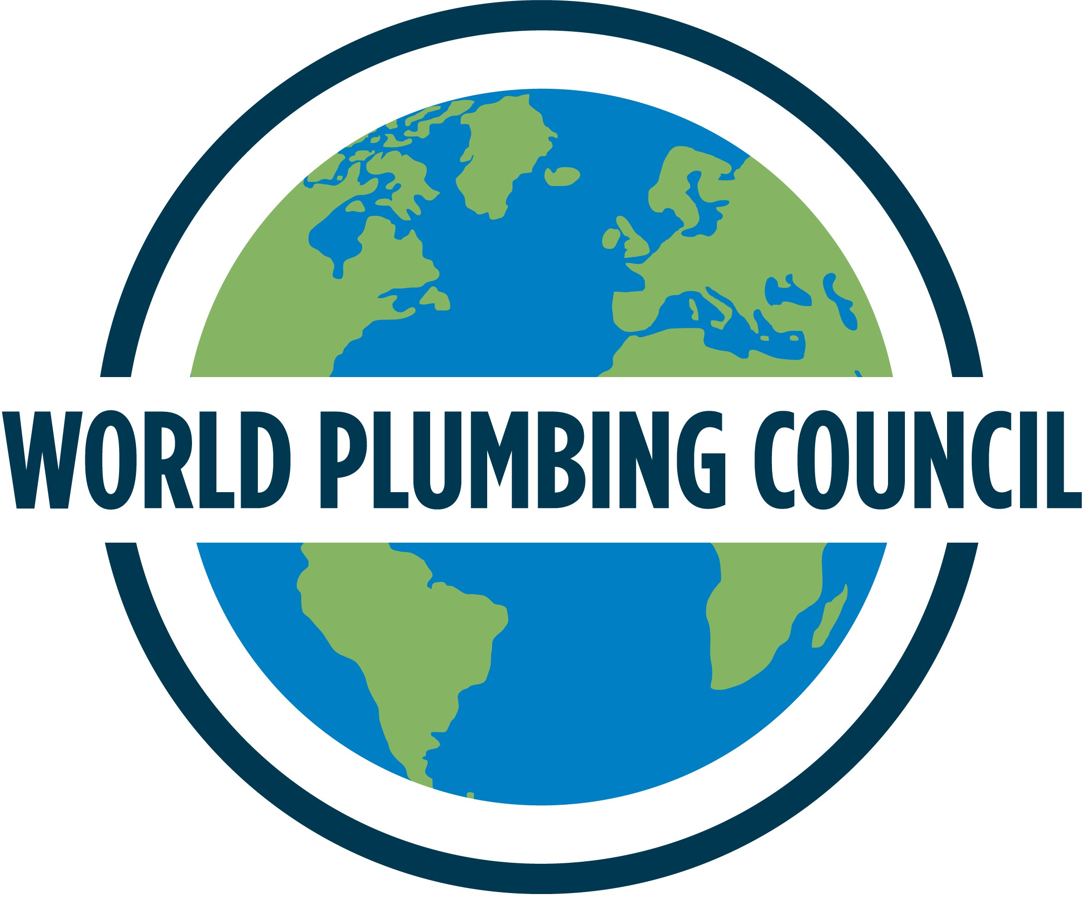
Expression of Interest -

World Plumbing Conference 2029

The WPC is seeking expressions of interest from Full Member organisations interested in being the local host for the World Plumbing Conference 2029 (WPC 2029).

WPC 2029 will be the 15th triennial World Plumbing Conference following WPC 2026 which will be held in Birmingham, England hosted by the Chartered Institute of Plumbing and Heating Engineering (CIPHE).

This form is to seek Expressions of Interest only. Following this period, a representative from the WPC will make contact regarding the next steps which will include preparing a formal Bid for WPC 2029. The Bid is made by representatives of your organisation to the WPC Executive Board.

Organisation:

Name of Contact:

Email address:

Phone number:

Brief outline of why your organisation is interested in hosting WPC 2029:

